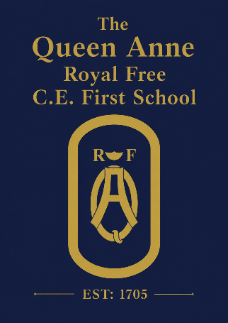

July 2026
Dear Parents and Carers,
As we reach the end of the academic year, I wanted to share an update from the Governing Board on what has been a year of meaningful progress for our school.
Academic Progress
Each year, governors review a detailed picture of how children are achieving and progressing across the school. This year's results show a strong upward trend, reflecting the progress made in developing the quality of teaching and behaviours for learning. We are particularly pleased with outcomes in Foundation Stage, where the proportion of children achieving a Good Level of Development is comfortably above previous years' national average, and with performance in the Year 1 phonics and Year 4 multiplication tables checks, where children also achieved above the previous year's national average. While these statutory assessments provide a useful snapshot, they do not capture the full breadth and richness of what children learn, experience and achieve at Queen Anne.
Perhaps most encouraging is what the data shows about children's progress over their whole time at Queen Anne. As we say farewell to our Year 4 leavers, we would like to recognise the progress they have made, with many meeting or exceeding expectations from their starting points. We are particularly proud that children who faced additional challenges along the way shared in that success. We congratulate our leavers on their achievements and wish them every success at middle school and beyond, while remaining focused on ensuring all children continue to make strong progress in all areas of the curriculum and personal development.

Royal Visit & Outdoor Learning
We were thrilled that the school welcomed HRH the Duchess of Edinburgh to the school this term, highlighting our commitment to outdoor learning and the links the school has built with local organisations. The Queen Anne's grounds and approach to learning beyond the classroom are something that set us apart and will be the focus of further development as part of our strategy. It was wonderful to have that acknowledged in such a special way.
Extreme Weather Policy
We know that the continuing spell of hot weather has been challenging for schools and families alike as we balance the need to keep children learning with their welfare; and recognise the role school plays in supporting working families. Governors’ are responsible for ensuring the school has appropriate policies in place to protect the safety of children and staff. As such we have recently approved an updated extreme weather policy outlining the procedures in place for such events, which we hope will reassure families on how the school manages these increasingly common conditions: this is available on the school website. The school is also actively looking at ways to mitigate hot weather in classrooms to reduce the need for future school closures.
Looking Ahead to Next Year
Next year promises to be an exciting one. Our refreshed school strategy will be launched at the start of the autumn term, setting out our ambitions for the school over the coming years. We very much look forward to sharing it with you and hearing your thoughts. The school will be welcoming new staff members to the teaching team, and we are confident they will bring further strength to what is already a committed and talented group of people. Curriculum will be the focus of further development next year as the new National Curriculum is made available; and we integrate that into a distinctive Queen Anne offer.
Above all, we go into next year with a clear sense of direction, a stronger foundation, and a great deal to build on.
Our People
As ever, the year has brought some changes to our school community. On the governing board, we say thank you and farewell to Dr. Kerry Howcroft, who’s term as a parent governor comes to an end; and our local authority governor Ms. Francesa Oakes, who has a new role as Deputy Head & SENCO at Claire’s Court school. Both have made valuable contributions during their time as governors and we wish them well. We are also pleased to welcome Mr. Mat Chilcot to the board as parent governor.
Thank You
None of what this year has achieved happens without the commitment of our staff, the engagement of our families, and a community that genuinely cares about this school. It is a privilege to serve a school community as engaged and generous as ours.
Wishing you a restful and joyful summer.
Warm regards,
Carly Talbot
Chair of Governors (on behalf of the Governing Board)

