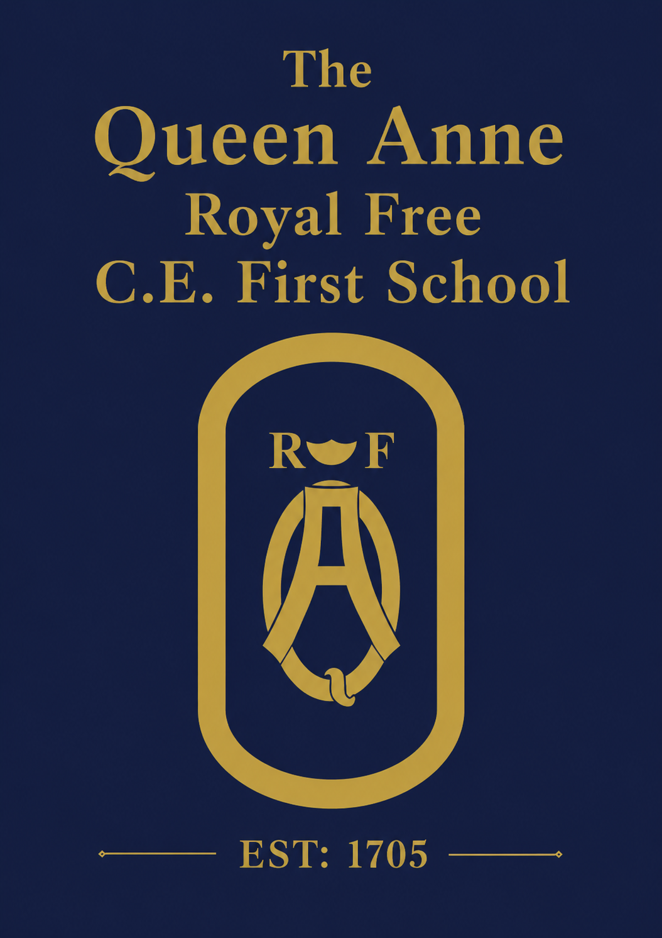

End of Year Newsletter

As we reach the end of another wonderful year at The Queen Anne, I would like to take a moment to reflect on a year defined by resilience, opportunity and achievement.
Our children have approached every challenge with curiosity, determination and enthusiasm. Supported by dedicated staff and strong partnerships with families, they have grown in confidence, developed academically and embraced the many opportunities that make life at The Queen Anne so special.

Resilience and Character
The year began in unusual circumstances following the discovery of an unstable tree adjacent to the school site, requiring all classes to learn in temporary outdoor marquees for a few days. What could have been a significant disruption instead became a powerful demonstration of our community's resilience. The children adapted with remarkable positivity, supported by committed staff and families, embodying the flexibility and character we strive to develop in every pupil.

The Queen Anne Experience
At The Queen Anne, education extends far beyond the classroom. We believe children flourish through rich experiences that inspire curiosity, develop confidence and create lasting memories.
This has truly been a year of firsts for our children. From Foundation Stage pupils taking their very first steps into school life to Year 4 preparing confidently for the next stage of their education, every child has experienced opportunities that have brought learning to life. Whether exploring history at Windsor Castle and Bocketts Farm, performing at the Parish Church, learning Japanese, becoming Eco Ambassadors or taking part in Citizen Science Projects and the Nature Study Pilot programme, each experience has broadened horizons and deepened learning.
The way our children have represented The Queen Anne have made us all feel proud this year. Wherever they have travelled, performed or welcomed visitors, they have demonstrated politeness, confidence and exemplary behaviour. The positive feedback we consistently receive is a testament to their character and to the values that underpin all we do.
Being part of The Queen Anne means belonging to far more than a school; it means becoming part of a caring, ambitious and outward-looking community. Through meaningful partnerships with local organisations, visiting specialists and our wider community, we provide opportunities that enrich learning, inspire ambition and help every child discover their unique strengths.

High Expectations and Achievement
Our commitment to high expectations remains unwavering. Through clear routines, consistent expectations and excellent teaching, our children continue to thrive in a calm and purposeful environment.
This year's outcomes continue to reflect the positive progress being made across the school and show continued improvement and an upwards trend. The results reflect the dedication of our staff, the support of our families and the sustained effort of our children.

Community and Celebration
School life has been enriched by many memorable occasions, including the Nativity, Easter Service and Garter Day.
We are especially grateful to QAPAFA for their continued generosity and support in providing memorable experiences for the children and parents alike.
Sports Day was a wonderful celebration of teamwork, perseverance and sporting spirit. It was inspiring to see every child participate with enthusiasm, encourage one another and demonstrate resilience alongside healthy competition. Congratulations to Dolphins, who were crowned our overall House Champions for 2025–26 following a year of outstanding participation and achievement.
We were delighted to be awarded the School Games Gold Mark Award in recognition of our commitment to providing high-quality sporting opportunities and promoting participation, competition and healthy lifestyles. This award reflects the enthusiasm of our pupils, the dedication of our staff and our belief that sport plays a vital role in developing confidence, resilience and teamwork.
Our Foundation Stage gardeners were delighted to receive a Silver Award at The Royal Windsor Rose & Horticultural Society's Flower Show 2026 for their Rooted in Nature wheelbarrow display. The award recognised not only the children's creativity and care, but also their growing understanding of the natural world through hands-on learning. It was a wonderful achievement and a fitting celebration of the curiosity, teamwork and pride that characterise life at The Queen Anne.
A particular highlight for the school was welcoming Her Royal Highness The Duchess of Edinburgh to The Queen Anne. It was a proud moment for our whole community and a wonderful opportunity to showcase The Nature Study Pilot programme and the unique experiences that define our school.
We also celebrate Mrs Wellstead's 25 years of dedicated service to The Queen Anne. Throughout this time, she has cared for, nurtured and inspired generations of children, making a lasting contribution to their education and development. We are incredibly grateful for her commitment, kindness and the many lives she has touched within our school community. Thank you, Mrs Wellstead!

Looking Ahead
As we say farewell to our Year 4 pupils and thank colleagues moving on to new opportunities, we reflect with pride on all that has been achieved this year.
Our Year 4 leavers' pupil survey provided a particularly heartening reflection on life at The Queen Anne. The strongest message throughout their responses was the appreciation of the caring relationships they have built with staff and friends during their time here. Children spoke fondly of the Year 4 residential, school trips, outdoor learning and memorable topics such as the Romans and Stone Age, recalling how these experiences brought learning to life. Many also reflected on the friendships they had made and the strong sense of belonging they felt within our school community. Above all, their responses reminded us that The Queen Anne is a community where children feel known, valued and supported. Year 4 leave us with wonderful memories, gratitude for the adults who have guided them and pride in being part of The Queen Anne family. Year 4, we will miss you all and wish you well.
Thank you to our pupils, staff, governors, parents and wider community for your continued support. Together, we have created another wonderful year.
I wish you all a restful and enjoyable summer break and look forward to welcoming everyone back in September for another year filled with learning, opportunity and success.
Mrs Street

