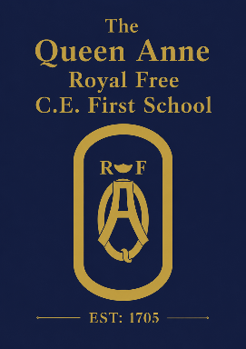

Music Development Summary September 26

Our Vision
At The Queen Anne, we believe music is an essential part of a rich and inspiring education. Through singing, performing, composing, listening and playing together, pupils develop creativity, confidence and self-expression while building a lifelong appreciation of music.
We are committed to providing an inclusive and ambitious music education where every child can participate, regardless of previous experience, and develop their musical skills and enjoyment.

Curriculum Music
All pupils receive weekly hour-long music lessons throughout the academic year. Our curriculum follows the Oak National Academy Music Scheme, which supports progression from Key Stage 1 to Key Stage 2 and is informed by the Model Music Curriculum.
Pupils develop their musicianship through:
- singing
- listening and responding to music
- composing and improvising
- performing
- appraising music
- developing musical vocabulary and understanding notation.
Children experience a wide range of musical styles, traditions, composers and cultures, supported by resources such as BBC Ten Pieces.

Singing and Instrumental Learning
Singing is central to music at The Queen Anne. Pupils sing regularly through music lessons, whole-school singing assemblies, collective worship, celebrations and performances.
All year groups develop rhythmic skills through untuned percussion as part of the curriculum. In Year 3, pupils begin learning a tuned instrument, such as the glockenspiel, through our partnership with Berkshire Music Trust. This learning continues into Year 4, developing confidence, musical independence and ensemble skills.

Performance and Musical Experiences
Every child has opportunities to perform throughout the year through school services, assemblies and productions, including our Year 4 Leavers’ Production. Pupils also experience live music through community singing events, visiting musicians, performances by peers and wider cultural experiences including an annual whole school theatre trip.

Co-curricular Music
Pupils are encouraged to extend their musical interests beyond classroom lessons.
Families are also signposted to opportunities through Berkshire Music Trust, including instrumental tuition, ensembles and county music groups.
Through Rock Steady Music Club, children can learn guitar, bass guitar, keyboard, drums and vocals while performing as part of a band. Weekly rehearsals and termly concerts help pupils develop confidence, teamwork, resilience and musicianship.

Partnerships and Inclusion
Our music provision is enriched through partnerships with Berkshire Music Trust, Rock Steady Music Club, specialist music teachers, our local parish church and Music Mark. We are proud to be a Music Mark member, recognising our commitment to high-quality music education.
Music at The Queen Anne is for every child. We make adaptations where needed to ensure all pupils, including those with SEND, can participate fully and experience success.
Costs
Curriculum music lessons, whole-school performances, celebrations and musical experiences provided as part of the school curriculum are free of charge. Additional musical opportunities, such as Rock Steady Club, are optional and are provided by external organisations; these may involve a charge set by the provider. The school is committed to ensuring that all pupils have access to musical opportunities and provides support where possible to promote inclusion and participation.

Future Development
Our priorities are to continue strengthening music across the school by:
- establishing a whole-school choir
- expanding performance opportunities
- developing partnerships with local music organisations
- increasing opportunities to experience high-quality live music
- continuing to develop staff expertise and curriculum provision.
Our aim is for every child to leave The Queen Anne with confidence, creativity and a lifelong love of music.

