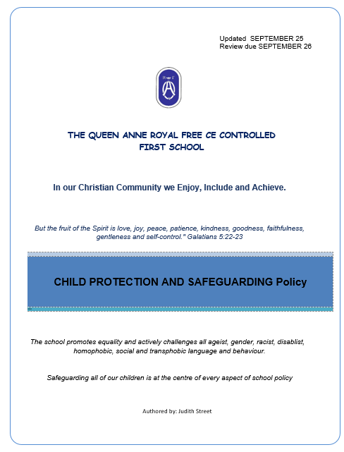

Safeguarding and
Child Protection Policy

Governors’ Committee Responsible | FULL GOVERNING BODY
Status | Statutory
Review Cycle | Annual
Date written/last review | 01 09 25
Date of next review | 01 09 26
Updated | March 2026- Working Together to Safeguard Children 2026

If you are worried about a child, go to Section 16 page 51
Contents
1. 12. 23. 34. 35. 55
6. 67. 118. 149. 1510. 15Recognising abuse 15
Physical abuse 15
Emotional abuse 15
Sexual abuse 16
Neglect 16
Indicators of abuse 17
Impact of abuse 18
Taking action 18
Mental health 18
Domestic abuse 19
Homelessness 20
Children with family members in prison 20
Contextual safeguarding and exploitation 20
Children missing education 21
Children who run away or go missing from home or care 22
Child sexual exploitation (CSE) 22
Child criminal exploitation (CCE) 26County lines 26
Serious youth violence 27
School related weapons incidents 28
Child on Child abuse 28
Bullying 29
Sexual violence and sexual harassment 30
Up skirting 33
Sharing nudes and semi-nudes 34
Cybercrime 37
Online safety 37
So-called ‘honour based’ abuse 38
Female genital mutilation (FGM) 39
Forced marriage 40
Child trafficking and modern slavery 41
Private fostering 43
Radicalisation and extremism 43
Suicide and self-harm 45
Fabricated or induced illnesses 46
11. 4947
12. 5048
13. 5114. 5149
15. 5216. 5517. 5618. 5719. 5753
20. 5821. 5822. 5923. 6024. 6325. 6358
26. 64Appendix 1 61
Concern reporting form 61
Appendix 2 63
Concerns flowchart 63
Appendix 3 64
Body map 64
Appendix 4 68
Links 68
Appendix 5 73
The Seven Rs 73

Terminology
- Safeguarding and promoting the welfare of children refers to the process of protecting children from maltreatment, preventing the impairment of children’s mental and physical health or development, ensuring that children grow up in circumstances consistent with the provision of safe and effective care and taking action to enable all children to have the best outcomes.
- Child protection refers to the processes undertaken to protect children who have been identified as suffering or being at risk of suffering significant harm.
- Staff refers to all individuals working for or on behalf of the school, whether full-time or part-time, temporary or permanent, and in either a paid or voluntary capacity. The term “staff” includes everyone on site, including ancillary staff, supply staff, self-employed individuals, contractors, volunteers, and Governors.

- Child includes all children under the age of 18, including unborn babies where there are concerns.
- Parent refers to birth parents and other adults who are in a parenting role, for example step-parents, foster carers and adoptive parents.
- External Partners: includes work with the police, health, social services& external agencies for pre-birth safeguarding

Introduction and purpose
This policy sets out how the governing board of The Queen Anne Royal Free CE First School is carrying out its statutory responsibility to safeguard and promote the welfare of children in accordance with Section 175 of the Education Act 2002.
The Queen Anne Royal Free CE First School fully recognises our moral and statutory responsibility to safeguard and promote the welfare of all pupils. This Safeguarding and Child Protection Policy is one of a range of documents that set out the safeguarding responsibilities of the whole school. We wish to create a safe, welcoming and vigilant environment for children where they feel valued and are respected.
Safeguarding information is published throughout the school and all children know who they can talk to in school and how they can make an anonymous disclosure using our class based ‘Worry Box’ system.
We recognise that the school may provide the only stability in the lives of children who have been abused or who are at risk of harm.
We are aware that the behaviour of a child in these circumstances may range from that which is perceived to be normal to aggressive or withdrawn.
We are able to play a significant part in the prevention of harm to our children by providing them with good lines of communication with trusted adults, supportive friends and an ethos of protection.
. It seeks to set out the principles and procedures we operate to protect children from harm. This policy provides information regarding our safeguarding responsibilities and details how these responsibilities should be carried out.
This policy will be updated as and when required and annually as a minimum. This may require our policy to be published ‘pending Governor ratification’.

Key personnel
Designated Safeguarding Lead  (DSL)  JUDITH STREET  Contact details 01753 830885 | Deputy Safeguarding Lead  LISA WARBURTON  RUKSANA BROACHI  Contact details 01753830883
Chair of Governors  Carly Talbot  Contact details: 01753830885 | Designated Governor for Safeguarding/ Child Protection  Reverend Sally Lodge  Contact details : 01753830883
Designated Teacher for Children Looked After  JUDITH STREET  Contact details 01753 830885 | SENDCo  FRANCESCA COLLIN  Contact details: 01753830883

School Health and Safety Officer : JUDITH STREET & ROSS KIRBY
KEY EXTERNAL CONTACTS
SPA: 01628 683150
OUT OF HOURS: 01344 786543
LADO: 07774 332675
lado@achievingforchildren.org.uk

Policy principles and aims
This policy aims to demonstrate to staff, Governors/Trustees, pupils, parents, stakeholders and other partners, The Queen Anne’s commitment to safeguarding and child protection.

The welfare of our children is paramount. All children, regardless of age, gender, culture, language, race, ability, sexual identity or religion have equal rights to protection, safeguarding and opportunities.

We recognise that all adults in our school have a full and active part to play in protecting our pupils from harm and have an equal responsibility to act on any suspicion or disclosure that may suggest a child is at risk of harm.
Our school is committed to developing a culture of safeguarding by providing an environment in which children and young people feel safe, secure, valued and respected and which promotes their social, physical and moral development. Children in our school feel confident to, and know how to approach adults if they are in difficulties.
This policy is used in conjunction with staff training and continued professional development to strengthen our whole school approach to safeguarding and to:
- raise staff awareness of the need to safeguard children and their responsibilities in identifying and reporting possible cases of abuse
- provide a systematic means of monitoring children known or thought to be at risk of harm, and ensure we, the school, contribute to assessments of need and support packages for those children
- emphasise the need for good levels of communication between all members of staff and develop and promote effective working relationships with other agencies, especially RBWM Multi Agency Safeguarding Board (https://rbwmsafeguardingpartnership.org.uk/) and the police
- develop a structured procedure within the school which will be followed by all members of the school community in cases of suspected abuse; ensure that the structured procedure is followed by school staff in cases of suspected abuse

- The school is an active partner within the local safeguarding arrangements and is committed to working collaboratively with safeguarding partners. This includes timely information sharing, contributing to multi-agency assessments and plans, attending and participating in key meetings, initiating and supporting Family Help, and providing professional challenge where necessary. The school ensures that the child’s voice is central to all safeguarding work and contributes to the continuous improvement of safeguarding practice across the partnership

Pupils and staff involved in child protection issues will receive appropriate support.

The Queen Anne has a culture of prevention and education in order to raise responsible, caring adults. The school encourages respectful behaviour and language to be used to all; a restorative approach to incidents of concern; and a wish to make reasonable adjustments to encourage students to remain in education, despite any difficulties. There is no tolerance of discriminatory language or abuse towards staff or students. There will be no use of alcohol for any events on site, whether involving staff, students, parents or Governors. There will be no use of alcohol by staff or students on school trips or at residential units.

Statutory framework, key statutory and
non-statutory guidance
To safeguard and promote the welfare of children, The Queen Anne will act in accordance with the following legislation and guidance:
- Children Act 1989 Care Planning, Placement and Case Review
- Children Act 2004
- Education Act 2002
- London Child Protection Procedures and Practice Guidance
- Keeping Children Safe in Education 2025
- Working Together to Safeguard Children 2026
- Inspecting Safeguarding in Early Years, Education and Skills
- Teachers' Standards
- What to do if You're Worried a Child is Being Abused
- Equality Act 2010: advice for schools
- Information Sharing
- Statutory framework for the early years foundation stage 2024

We take seriously our responsibility to ensure that we have appropriate procedures in place for responding to situations in which we believe that a child has been abused or is at risk of abuse.
Our procedures also cover circumstances in which a member of staff is accused of, or suspected of, abuse, including low level concerns.
We will take steps to ensure that any groups or individuals who hire and/or use our building or grounds inside or outside of school hours, follow the local child protection guidelines and are aware of their safeguarding duties and this policy.
We will ensure that all staff read and understand:
- The Queen Anne’s Safeguarding and Child Protection policy
- The Queen Anne online safeguarding policy
- Keeping Children Safe in Education (2025) [Part One] and school leaders and staff that work directly with children will also read Annex B
- The Queen Anne code of conduct
- The Queen Anne Behaviour Policy

We will ensure that all staff are aware of:
- the safeguarding response to children who go missing from education
- The role of the Designated Safeguarding Lead
- The identity of The Queen Anne’s Designated Safeguarding Lead and Deputy(ies)
- The additional vulnerabilities of children who are looked after/previously looked after, children with Special Educational Needs and Disabilities and children who are young carers.

Copies of the above documents will be provided to all staff as part of the induction process.

The Queen Anne will publish our Safeguarding and Child Protection policy on our website and hard copies will be available on request from the school office.

The roles of the Designated Safeguarding Lead and the Deputy Designated Safeguarding Lead(s) will be explicit in their job descriptions, and we will ensure that they have the time and resources to fulfil their duties.

Roles and responsibilities
The Governing Board/Board of Trustees
Safeguarding is a standing item on the agenda for every meeting of the full board.
The Governing Board/Board of Trustees of The Queen Anne understands and fulfils its responsibilities, namely to ensure that:
- they liaise with the headteacher and/or designated teachers over safeguarding matters. This is a strategic role rather than operational. Governors will not be involved in concerns regarding individual children
- there is a Safeguarding and Child Protection policy that reflects the whole school approach to peer-on-peer abuse
- there is a Staff Behaviour policy/Code of Conduct that includes the process for responding to low level concerns and acceptable use of technology
  - child protection, safeguarding, recruitment and managing allegations policies and procedures, including the Staff Behaviour Policy (Code of Conduct), are consistent with RBWM Multi Agency Safeguarding Board (https://rbwmsafeguardingpartnership.org.uk/) and statutory requirements. They are reviewed when needed and annually as a minimum. The Safeguarding and Child Protection policy is publicly available on the school website
  - all staff, including temporary staff and volunteers sign to say they have read, understood and agree to work within The Queen Anne Safeguarding and Child Protection policy and Staff Behaviour policy (Code of Conduct)
  - all staff sign to say they have read and understood Keeping Children Safe in Education (2025) part 1 and Annex B and that mechanisms are in place to assist staff in understanding and discharging their roles and responsibilities as set out in the guidance
  - all Governors/Trustees sign to say they have read and understood Keeping Children Safe in Education (2025) and the Safeguarding and Child Protection Policy
  - the school operates a safer recruitment procedure that includes statutory checks on staff suitability to work with children and ensure that there is at least one person on every recruitment panel who has completed safer recruitment training within the last five years
  - The Queen Anne has procedures for dealing with allegations of abuse against staff (including the headteacher), volunteers and against other children and that a referral is made to the DBS if a person in regulated activity has been dismissed or removed due to safeguarding concerns, or would have been had they not resigned
  - the Governing Board has at least one nominated governor responsible for safeguarding who has undertaken appropriate training for the role. The chair of governors is responsible in the event of an allegation of abuse made against the headteacher
  - an annual audit of name of school’s safeguarding policies, procedures and practices is undertaken with the headteacher and designated safeguarding lead (DSL) and that this is reported to the Board and submitted to RBWM Multi Agency Safeguarding Board (https://rbwmsafeguardingpartnership.org.uk/)
  - The Queen Anne is aware of relevant legislation and local guidance, which has been agreed through the local safeguarding partnership arrangements
  - there are clear lines of accountability for safeguarding within the school’s leadership
  - a member of the senior leadership team has been appointed as the designated safeguarding lead and they will take lead responsibility for safeguarding and child protection; the role is explicit in the role holder’s job description
  - DSLs and their deputy(ies) undertake multi-agency (Level 3) safeguarding training which is updated every two years
  - there is a designated teacher to promote the educational achievement of children looked after who are on the school roll
  - all members of the Governing Board receive safeguarding training. The safeguarding Governor attends appropriate training that guides governors in their strategic responsibilities to provide appropriate challenge and support for any action and to progress areas of weakness or development in the school’s safeguarding arrangements
  - at least one member of the Governing Board has completed safer recruitment training to be repeated every five years
  - children are taught about safeguarding (including online safety) as part of a broad and balanced curriculum covering relevant issues through personal, social, health and economic education (PSHE) and through relationships education or relationships and sex education (RSE)
  - appropriate safeguarding responses are in place for children who go missing from education, particularly on repeat occasions, to help identify the risk of abuse, neglect or exploitation including sexual abuse or exploitation and to help prevent the risks of their going missing in future
  - appropriate online filtering and monitoring systems are in place - staff must have ‘an understanding of the expectations, applicable roles and responsibilities in relation to filtering and monitoring. The school’s approach to online safety, including appropriate filtering and monitoring on school devices and school networks and which include awareness of the ease of access to mobile phone networks (see The Queen Anne Internet Policy)
https://www.gov.uk/guidance/meeting-digital-and-technology-standards-in-schools-and-colleges/filtering-and-monitoring-standards-for-schools-and-colleges
  - We will
  - identify and assign roles and responsibilities to manage filtering and monitoring systems.
  - review filtering and monitoring provision at least annually.
  - block harmful and inappropriate content without unreasonably impacting teaching and learning.
  - have effective monitoring strategies in place that meet their safeguarding needs.
  - Further, governing bodies and proprietors should review the standards and discuss with IT staff and service providers what more needs to be done to support schools in meeting this standard.
  - There are also links to the additional guidance on filtering and monitoring from the UK Safer Internet Centre and their related toolkit.

  - enhanced Disclosure and Barring Service (DBS) checks (without barred list checks, unless the governor is also a volunteer at the school) are in place for all governors

The headteacher
The headteacher will ensure that:
- the safeguarding and child protection policy and related policies and procedures are implemented and followed by all staff
  - sufficient time, training, support, resources, including cover arrangements where necessary, is allocated to the DSL and deputy(ies) to carry out their roles effectively
  - systems are in place for children to express their views and give feedback, which operate with the best interests of the child at heart
  - all staff feel able to raise concerns about poor or unsafe practice and that such concerns are handled sensitively and in accordance with the whistleblowing/managing allegations against staff procedures
  - pupils are provided with opportunities throughout the curriculum to learn about safeguarding, including keeping themselves safe online. The PSHE curriculum is reviewed regularly to ensure that it remains relevant and current
  - behaviour expectations around the whole school site will be consistent with the safeguarding and relationship lessons taught in the classroom
  - they liaise with the local authority designated officer (LADO) within 24 hours before taking any action, and then on an ongoing basis, where an allegation is made against a member of staff or a volunteer

The designated safeguarding lead (DSL)
- holds lead responsibility for safeguarding and child protection in The Queen Anne. This responsibility will not be delegated
- acts as a source of support and expertise for the whole school community in regards to our safeguarding duties
- encourages a culture of listening to children and taking account of their wishes and feelings
- undertakes multi-agency (Level 3) safeguarding training with updates every two years and will refresh their knowledge and skills at regular intervals but at least annually
- undertakes Prevent awareness training
- will refer a child if there are concerns about possible abuse to AfC’s Single Point of Access (SPA) and/or the local authority where the child resides and act as a focal point for staff to discuss concerns
- will keep detailed, accurate records, either written or using appropriate online software, of all concerns about a child, even if there is no need to make an immediate referral
- will ensure that all such records are kept confidential, stored securely and are separate from the pupil’s general file
- will ensure that an indication of the existence of the additional safeguarding and child protection file is marked on the pupil general file
- will ensure that a copy of the safeguarding and child protection file is retained until such time that the new school acknowledges receipt of the original file. The copy will then be shredded
- will liaise with the local authority and work with other agencies and professionals in line with Working Together to Safeguard Children 2026.
- has a working knowledge of RBWM Multi Agency Safeguarding Board (https://rbwmsafeguardingpartnership.org.uk/) and AfC procedures. Will ensure that either they, or an appropriate staff member, attend case conferences, core groups, or other multi-agency planning meetings, contribute to assessments and provide a report, where required, which has been shared with the parents and child (depending on age and understanding)
- notifies Children’s Social Care if a child subject to a child protection plan is absent from school without explanation
- will ensure that all staff sign to say they have read, understood and agree to work within name of school’s safeguarding and child protection policy, staff behaviour policy (code of conduct) and Keeping Children Safe in Education 2025 Part 1 and Annex A and ensure that the policies are used appropriately
- will organise child protection and safeguarding induction, regularly updated training and a minimum of annual updates (including online safety) for all school staff, keep a record of attendance and address any absences
- will undertake, with the headteacher and Governing Board, an annual audit of The Queen Anne safeguarding policies, procedures and practices and ensure that this is submitted to RBWM Multi Agency Safeguarding Board (https://rbwmsafeguardingpartnership.org.uk/)
- Has an understanding of locally agreed processes for providing Family Help and intervention and will support members of staff where Family Help is appropriate
- can recognise the additional risks that children with SEN and disabilities (SEND) face online, for example from online bullying, grooming and radicalisation
- will help to promote educational outcomes by sharing the information about the welfare, safeguarding and child protection issues that children, including children with a social worker, are experiencing, or have experienced, with teachers and leadership staff
- will ensure that the name of the designated safeguarding lead and deputies are clearly advertised in the school and on the website, with a statement explaining the school’s role in referring and monitoring cases of suspected abuse
- will ensure that they, or a deputy, are available during term time school hours for staff to discuss any safeguarding concerns
- will ensure that there are adequate and appropriate cover arrangements for any out of hours or out of term activities.
• In line with Working Together to Safeguard Children 2026, the Designated Safeguarding Lead will ensure that safeguarding practice includes direct work with children where appropriate. This includes actively seeking and recording the child’s voice, understanding their lived experience, and ensuring that they are seen, heard, and supported. The DSL will build or facilitate trusted relationships, use professional curiosity, and ensure that the child’s wishes and feelings inform all safeguarding decisions and multi-agency work. Direct work will be ongoing, with appropriate follow-up to ensure the child’s safety and wellbeing.

This list is not exhaustive: please see Annex C of Keeping Children Safe in Education 2025

A deputy designated safeguarding lead(s)
- is trained to the same standard as the designated safeguarding lead and, in the absence of the DSL, carries out those functions necessary to ensure the ongoing safety and protection of pupils. In the event of the long-term absence of the DSL the deputy will assume all of the functions above.
All school staff and volunteers
- understand that it is everyone’s responsibility to safeguard and promote the welfare of children and that they have a role to play in identifying concerns, sharing information and taking prompt action
- undertake safeguarding and health and safety training appropriate to their role and are familiar with the suite of safeguarding policies including the Safeguarding and Child Protection policy and Staff Behaviour policy (Code of Conduct)
- consider at all times what is in the best interests of the child
- know how to respond to a pupil who discloses abuse
- will refer any safeguarding or child protection concerns to the DSL or ,if necessary where the child is at immediate risk, to the police or Single Point of Access (SPA), or if a child lives out of borough, to the relevant local authority
- will provide a safe environment in which children can learn.

Safe school, safe staff
We will ensure that:
- at least one member of every recruitment panel has completed safer recruitment training within the last five years
- safer recruitment practices are adhered to including appropriate DBS checks, reference checks and any additional checks relevant to the role undertaken. The Queen Anne has a Safer Recruitment Policy which is available as a separate document
- all staff are aware of the need for maintaining appropriate and professional boundaries in their relationship with staff, pupils and parents and adhere to The Queen Anne code of conduct
- as a result of learning from a local Serious Case Review, there will be no alcohol for any events on site during the school day involving staff, pupils, parents or Governors
- as a result of learning from a local Serious Case Review, there will be no use of alcohol by staff or pupils on school trips or at residential units
- our lettings policy will seek to ensure the suitability of adults working with children on school sites at any time
- adequate risk assessments are in place including for off-site activities, after school clubs and residential trips
- any disciplinary proceedings against staff related to child protection matters are concluded in full in accordance with Government guidance Keeping Children Safe in Education 2025, RBWM Multi Agency Safeguarding Board LADO and HR policy, procedures and guidance
- staff have the confidence, and are fully aware of how to report misconduct, including low level concerns
- all staff receive information about The Queen Anne safeguarding arrangements, safeguarding statement, Staff Behaviour Policy (Code of Conduct), Safeguarding and Child Protection policy, the role and names of the DSL and their deputy(ies), and Keeping Children Safe in Education part 1 and Annex A on induction, as well as other relevant procedures such as health and safety and online safety
- all staff receive safeguarding and child protection training at induction, which is regularly updated. In addition, they receive safeguarding and child protection updates (for example, via email, e-bulletins and staff meetings) as required, but at least annually
- all members of staff are trained in and receive regular updates in online safety and reporting concerns
- all staff and governors have regular safeguarding awareness training, updated by the DSL as appropriate, to maintain their understanding of the signs and indicators of abuse
- the safeguarding and child protection policy is made available via our school website or other means and parents and carers are made aware of this policy and their entitlement to have a copy via the school handbook, newsletter or website
- all parents and carers are made aware of the responsibilities of staff members with regard to child protection procedures through the publication of the safeguarding and child protection policy and reference to it in our school’s handbook
- The Queen Anne provides a co-ordinated offer of Family Help when additional needs of children are identified and contributes to Family Help arrangements and inter-agency working and plans, such as school attendance at the Family Help Resilience Network meetings
- community users organising activities for children are aware of The Queen Anne safeguarding and child protection policy, guidelines and procedures
- the names of the DSL and deputy(ies) are clearly advertised in the school with a statement explaining the The Queen Anne role in referring and monitoring cases of suspected abuse
- all staff will be given a copy of Part 1 and Annex A of Keeping Children Safe in Education 2025 and will sign to say they have read and understood it. The DSL and the Governing Board are required to read the whole document.

Extended school and off-site arrangements
- Where extended school activities are provided by and managed by the school, our own safeguarding and child protection policy and procedures apply.
- If other organisations provide services or activities on our site, we will ensure that they have appropriate procedures in place, including safer recruitment procedures.
- When our pupils attend off-site activities, we will ensure that effective child protection arrangements are in place.
- When our pupils attend an alternative provision provider, we will obtain written confirmation that appropriate safeguarding checks have been carried out on individuals working at the establishment, i.e. those checks that we would otherwise perform in respect of our own staff. We follow the statutory guidance for alternative provision and the Alternative Provision handbook alongside the Quality Assurance evaluation framework.
- Where a parent/carer has expressed their intention to remove a child from our school with a view to educating at home, we will work together with the parent/carer, EHE Coordinator and other professionals to ensure that this decision has been made in the best interests of the child. We recognise that this is particularly relevant where a child has SEND, is vulnerable, and/or has a social worker.

Media recordings, audio, image and video (including digital files)
The vast majority of people who take or view images or videos of children do so for entirely innocent, understandable and acceptable reasons. Sadly, some people abuse children through taking or using images, so we must ensure that we have some safeguards in place. To protect pupils, we will:
- seek their consent and parental consent for photographs to be taken or published (for example, on our website or in newspapers or publications)
- use only the pupil’s first name with an image
- ensure that pupils are appropriately dressed
- encourage pupils to tell us if they are worried about any photographs that are taken of them
- ensure that pupils do not take photographs or video images of other students without their express permission and the permission of a member of staff
Staff are permitted to make media recordings to support educational aims but must follow our policies in respect of sharing, distribution and publication. Media images must be taken, edited, stored or archived on to school systems using school equipment.

Training
All staff members and volunteers receive appropriate safeguarding and child protection training, including induction, which is regularly updated. This includes training on how to recognise signs of abuse and how to respond to any concerns. In addition, all staff members receive safeguarding and child protection updates (for example, via email, e-bulletins and staff meetings) as required, but at least annually, to provide them with relevant skills and knowledge to safeguard children effectively. Staff also receive regular online safety training.
The nominated safeguarding Governor(s) undergo(es) safeguarding training prior to or as soon as appointment to the role and at regular intervals thereafter.
The DSL attends the multi-agency Local safeguarding partnership training within 12 weeks of taking up their responsibilities.
The Queen Anne ensures that its DSL attends the Designated Safeguarding Lead training and conferences/Networks to keep abreast of child protection learning and developments, at least biannually.
We ensure that staff members provided by other agencies and third parties, e.g. supply teachers and contracted staff, such as catering staff, are aware of our Safeguarding and Child Protection policy and procedure, and have received appropriate safeguarding training.

Training:
All Staff and Governors:
- Annual Safeguarding Training
- Ongoing refreshers and updates throughout the year

Teaching and Learning
Safeguarding is included in specific areas of teaching and learning, for example PSHE, SMSC, RSE, assemblies and tutor time. We work with the N.S.P.C.C who deliver safeguarding sessions and workshops.
Areas covered may include:
- consent
- personal safety
- who to talk to
- road safety
- fire safety
- online safety* including misinformation, disinformation (including fake news) and conspiracy theories
- bullying (including online bullying)
- positive relationships
- self-esteem
- drugs and alcohol
- RSHE guidance link (see note on first page)

Child protection overview and specific safeguarding concerns

Recognising abuse
To ensure that our pupils are protected from harm, we need to understand what types of behaviour constitute abuse and neglect.
Abuse, neglect or exploitation are forms of maltreatment. Somebody may abuse or neglect a child by inflicting harm, for example by hitting them, or by failing to act to prevent harm, for example by leaving a small child home alone, or leaving knives or matches within reach of an unattended toddler.
Abuse may be committed by adult men or women and by other children and young people.
There are four categories of abuse.

Physical abuse
Physical abuse is a form of abuse that may involve hitting, shaking, throwing, poisoning, burning or scalding, drowning, suffocating or otherwise causing physical harm to a child. Physical harm may also be caused when a parent or carer fabricates the symptoms of, or deliberately induces, illness in a child (this used to be called Munchausen’s Syndrome by Proxy, but is now more usually referred to as fabricated or induced illness).

Emotional abuse
Emotional abuse is the persistent emotional maltreatment of a child such as to cause severe and persistent adverse effects on the child’s emotional development. It may involve conveying to a child that they are worthless or unloved, inadequate, or valued only insofar as they meet the needs of another person. It may include not giving the child opportunities to express their views, deliberately silencing them or ‘making fun’ of what they say or how they communicate. It may feature age or developmentally inappropriate expectations being imposed on children.
These may include interactions that are beyond a child’s developmental capability, as well as overprotection and limitation of exploration and learning, or preventing the child participating in normal social interaction. It may involve seeing or hearing the ill-treatment of another and this particularly relevant when children see, hear or experience domestic abuse and its effects. It may involve serious bullying (including online bullying), causing children frequently to feel frightened or in danger, or the exploitation or corruption of children. Some level of emotional abuse is involved in all types of maltreatment of a child, although it may occur alone.
Sexual abuse
Sexual abuse involves forcing or enticing a child or young person to take part in sexual activities, not necessarily involving a high level of violence, whether or not the child is aware of what is happening. The activities may involve physical contact, including assault by penetration (for example, rape or oral sex) or non-penetrative acts such as masturbation, kissing, rubbing and touching outside of clothing.
They may also include non-contact activities, such as involving children in looking at, or in the production of, sexual images, watching sexual activities, encouraging children to behave in sexually inappropriate ways or grooming a child in preparation for abuse (including via the internet). Sexual abuse is not solely perpetrated by adult males. Women can also commit acts of sexual abuse, as can other children.
Our school is aware of the impact of the Everyone’s Invited website and the prevalence of harmful sexual behaviour. We encourage all pupils to speak out either in person or to report concerns using our anonymous reporting system.

Neglect
Neglect is the persistent failure to meet a child’s basic physical and/or psychological needs, likely to result in the serious impairment of the child’s health or development. Neglect may occur during pregnancy as a result of maternal substance abuse. Once a child is born, neglect may involve a parent or carer failing to:
- provide adequate food, clothing and shelter (including exclusion from home or abandonment)
- protect a child from physical and emotional harm or danger
- ensure adequate supervision (including the use of inadequate care-givers)
- ensure access to appropriate medical care or treatment. It may also include neglect of,
or unresponsiveness to, a child’s basic emotional needs
Definitions taken from Working Together to Safeguard Children (HM Government, 2018)
Working Together to Safeguard Children 2026
Neglect can occur in affluent families and can also centre around Educational Neglect.

Threshold Document

Indicators of abuse
Physical signs define some types of abuse, for example bruising, bleeding or broken bones resulting from physical or sexual abuse, or injuries sustained while a child has been inadequately supervised. The identification of physical signs is complicated, as children may go to great lengths to hide injuries, often because they are ashamed or embarrassed, or their abuser has threatened further violence or trauma if they ‘tell’. It is also quite difficult for anyone without medical training to categorise injuries into accidental or deliberate with any degree of certainty. For those reasons it is vital that staff are also aware of the range of behavioural indicators of abuse and report any concerns to the designated safeguarding lead.
It is the responsibility of staff to report their concerns. It is not their responsibility to investigate or decide whether a child has been abused.
A child who is being abused or neglected may:
- have bruises, bleeding, burns, fractures or other injuries
- show signs of pain or discomfort
- keep arms and legs covered, even in warm weather
- be concerned about changing for PE or swimming
- look unkempt and uncared for
- change their eating habits/be hungry/take food from others
- have difficulty in making or sustaining friendships
- appear fearful/anxious
- be reckless with regard to their own or others' safety
- self-harm
- low self-esteem
- frequently miss school or arrive late
- show signs of not wanting to go home
- display a change in behaviour – from quiet to aggressive, or happy-go-lucky to withdrawn
- challenge authority
- become uninterested in their school work
- be constantly tired or preoccupied
- be wary of physical contact
- be involved in, or particularly knowledgeable about drugs or alcohol
- display sexual knowledge or behaviour beyond that normally expected for their age and/or stage of development
- acquire gifts such as money or a mobile phone from new ‘friends’ or adults recently acquainted with the child’s family
Individual indicators will rarely, in isolation, provide conclusive evidence of abuse. They should be viewed as part of a jigsaw and each small piece of information will help the DSL to decide how to proceed.
It is very important that staff report all of their concerns, however minor or insignificant they may think they are – they do not need ‘absolute proof’ that the child is at risk.

Impact of abuse
The sustained abuse or neglect of children physically, emotionally or sexually can have long term effects on the child’s health, development and wellbeing. It can impact significantly on a child’s self-esteem, self-image and on their perception of self and of others. The more Adverse Childhood Experiences (ACEs) a child has, the more likely they are to suffer long term. The effects can extend into adult life and lead to difficulties in forming and sustaining positive and close relationships. In some situations, it can affect parenting ability.
ACEs video

Taking action
Any child in any family in any school could become a victim of abuse. Staff should always maintain an attitude of ‘It could happen here’.

Key points for staff to remember when taking action are:
- in an emergency, take the action necessary to help the child, for example call 999
- report your concern to the DSL as quickly as possible – immediately when there is evidence of physical or sexual abuse and certainly by the end of the day
- do not start your own investigation
- share information on a need-to-know basis only – do not discuss the issue with colleagues, friends or family
- complete a record of concern, using CPOMS and seek support for yourself if you are distressed or need to debrief

Mental health
Mental health issues affect at least 1 in 10 children and young people. They include depression, anxiety, low self-esteem, disordered eating, panic attacks, sleep problems and many other conditions and behaviours. They are often a direct response to what is happening in their lives.
The Queen Anne recognises that mental health issues can, in some cases, be an indicator that a child has suffered or is at risk of suffering abuse, neglect or exploitation and is aware that only appropriately-trained professionals should attempt to make a diagnosis of a mental health problem. However, staff are well placed to observe children day-to-day and identify those whose behaviour suggests that they may be experiencing a mental health issue, or be at risk of developing one.

Possible warning signs include:

- Persistent sadness — two or more weeks
- Withdrawing from or avoiding social interactions
- Hurting oneself or talking about hurting oneself
- Talking about death or suicide
- Outbursts or extreme irritability
- Out-of-control behaviour that can be harmful
- Drastic changes in mood, behaviour or personality
- Changes in eating habits
- Loss of weight
- Difficulty sleeping
- Frequent headaches or stomach aches
- Difficulty concentrating
- Changes in academic performance
- Avoiding or missing school

The Queen Anne aims to promote positive mental health for all staff and pupils.
Our mental health lead is: Judith Street and Francesca Collin ( Senco)
Support available includes- ELSA, Drawing and Talking, Mindfulness.
Signposting to Family Help services.
A bespoke package of support will be identified on a case by case basis
Referrals are made by SENCO in liaison with parents

The Queen Anne will ensure that staff, pupils and parents are made aware of the support available in school and in the local community.

Useful links: Mental health and behaviour in schools guidance NSPCC Mind Kooth and The Mental Health Toolkit

Domestic abuse
The Domestic Abuse Act 2021 recognises the impact of domestic abuse on children, as victims in their own right if they see, hear or experience the effects of abuse.
The abuse can encompass, but is not limited to:
- psychological
- physical
- sexual
- economic
- emotional
• Coercive control
• Relationship abuse
- Online exploitation
All children can witness and be adversely affected by domestic abuse in the context of their home life where domestic abuse occurs.
The Queen Anne recognises that exposure to domestic abuse can have a serious, long-lasting emotional and psychological impact on children. In some cases, a child may blame themselves for the abuse or may have had to leave the family home as a result. The Queen Anne acknowledges that domestic abuse affecting young people can also occur within their personal relationships, as well as in the context of their home life.
The Queen Anne as signed up to the police initiative Operation Encompass that helps the school to provide silent support to children. The system ensures that when police are called to an incident of domestic abuse, where there are children in the household who have experienced the domestic incident, the police will inform the DSL in school before the child or children arrive at school the following day. This ensures that the school has up-to-date relevant information about the child’s circumstances and can enable silent support to be given to the child according to their needs. Operation Encompass

Homelessness
The Queen Anne recognises that being homeless or being at risk of becoming homeless presents a real risk to a child’s welfare. The DSL is aware of contact details and referral routes into the Local Housing Authority so they can raise/progress concerns at the earliest opportunity.
Indicators that a family may be at risk of homelessness include:
- household debt, including new poverty induced by the pandemic
- rent arrears
- domestic abuse and antisocial behaviour
- the family being asked to leave a property

If a child has been harmed or is at risk of harm, a referral to children’s social care will be made.

Children with family members in prison
The Queen Anne recognises that children who have a family member in prison are at risk of poor outcomes including poverty, stigma, isolation and poor mental health. The school will work with agencies and resources such as NICCO to help mitigate negative consequences for those children.

Contextual safeguarding and exploitation
Contextual Safeguarding is an approach to understanding, and responding to, young people’s experiences of significant harm beyond their families. It recognises that the different relationships that young people form in their neighbourhoods, schools and online can feature violence and abuse. Parents and carers have little influence over these contexts, and young people’s experiences of extra-familial abuse can undermine parent-child relationships.
The focus of contextual safeguarding and exploitation (CS&E) is implementing child safeguarding practices into community spaces to ensure that children are protected from the harm they experience outside of the family home. This focus moves beyond just assessing parenting capacity to safeguard a child at home, to assessing the impact of peer groups and community spaces (schools and neighbourhoods) on a child’s safety and wellbeing outside the home.
It looks to identify the influences outside the family that can impact the parent-child relationship and the safety of a child in the community. It then adapts the child protection systems, safeguarding partnerships, and creates new professional networks with those who have an influence in the location so that the identified child, their family and the community are safe.
The Queen Anne will maintain records of concerns about extrafamilial harm in the same way as other concerns are recorded and in accordance with our safeguarding procedures.
Concerns relating to significant harm and extrafamilial harm will be referred by the DSL to the Single Point of Access Team; if considered appropriate, a multi-agency strategy meeting will be held to determine threshold for significant harm.
the Assessment Triangle (PDF)
RBWM threshold

Children missing education
We recognise that full attendance at school is important to the wellbeing of all our pupils and enables them to access the opportunities made available to them at school. Attendance is monitored closely and we work in partnership with AfC when patterns of absence give rise to concern.
A child going missing from education is a potential indicator of abuse and neglect, including sexual abuse and sexual exploitation and can also be a sign of child criminal exploitation, including involvement in county lines. It may indicate mental health problems, risk of substance abuse, risk of travelling to conflict zones, risk of female genital mutilation or risk of forced marriage and other harmful practices.
We will ensure, where possible, that we have more than one emergency contact number for each pupil. This will give the school additional options to make contact with a responsible adult when a child missing education is also identified as a welfare and/or safeguarding concern.
Our attendance policy is set out in a separate document and is reviewed regularly by the Governing Board. The school operates in accordance with statutory guidance Children missing education: statutory guidance for local authorities
RBWM CME policy & referral: Local Guidance

Children who run away or go missing from home or care
The Queen Anne recognises that children who run away or go missing - and are thus absent from their normal residence - are potentially vulnerable to abuse, exploitation, offending and placing themselves in situations where they may suffer physical harm.
‘Keeping Children Safe in Education 2025’ highlights that 'Statutory Guidance on Children who Run Away or go Missing from Home or Care' (DfE 2014) requires that every child or young person who runs away or goes missing must be offered a return home interview (RHI) within 72 hours of their return.
When necessary and in conjunction with AfC or other relevant local authority, The Queen Anne will facilitate return home interviews, both in terms of releasing the young person from their normal timetable to participate in an interview and in providing an appropriate and safe space on the school or college site for the interview to take place.
children who run away or go missing from home or care

As a school we refer to statutory DfE guidance on attendance related where safeguarding us a concern
Working together to improve school attendance (applies from 19 August 2024)

Child sexual exploitation (CSE)
The Queen Anne follows the London Child Protection Procedures for safeguarding children from sexual exploitation. Safeguarding Children from Sexual Exploitation
In February 2017, the government updated the working definition of child sexual exploitation Child sexual exploitation definition and guide

“Child sexual exploitation is a form of child sexual abuse. It occurs where an individual or group takes advantage of an imbalance of power to coerce, manipulate or deceive a child or young person under the age of 18 into sexual activity (a) in exchange for something the victim needs or wants, and/or (b) for the financial advantage or increased status of the perpetrator or facilitator.
“The victim may have been sexually exploited even if the sexual activity appears consensual. Child sexual exploitation does not always involve physical contact; it can also occur through the use of technology.”

Child sexual exploitation is a form of child sexual abuse affecting boys and girls. Sexual abuse may involve physical contact, including assault by penetration (for example, rape or oral sex) or non-penetrative acts such as masturbation, kissing, rubbing and touching outside clothing. It may include non-contact activities, such as involving children in the production of sexual images, forcing children to look at sexual images or watch sexual activities, encouraging children to behave in sexually inappropriate ways or grooming a child in preparation for abuse (including via the internet).
Child sexual exploitation may occur without the child being aware of events, or understanding that these constitute abuse.
Child sexual exploitation is never the victim’s fault, even if there is some form of exchange: all children and young people under the age of 18 have a right to be safe and should be protected from harm.

Child sexual exploitation:
- can affect any child or young person (male or female) under the age of 18, including 16 and 17 year olds who can legally consent to have sex
- can still be abuse even if the sexual activity appears consensual
- can include both contact (penetrative and non-penetrative acts) and non-contact sexual activity
- can take place in person or via technology, or a combination of both
- can involve force and/or enticement-based methods of compliance and may, or may not, be accompanied by violence or threats of violence
- may occur without the child’s or young person’s immediate knowledge (through others copying videos or images they have created and posting on social media, for example)
- can be perpetrated by individuals or groups, males or females, and children or adults. The abuse can be a one-off occurrence or a series of incidents over time, and range from opportunistic to complex organised abuse
- is typified by some form of power imbalance in favour of those perpetrating the abuse. While age may be the most obvious, this power imbalance can also be due to a range of other factors including gender, sexual identity, cognitive ability, physical strength, status, or access to economic or other resources

Consent
Even where a young person is old enough to legally consent to sexual activity, the law states that consent is only valid where they make a choice and have the freedom and capacity to make that choice. If a child feels they have no other meaningful choice, are under the influence of harmful substances or fearful of what might happen if they don’t comply (all of which are common features in cases of child sexual exploitation), consent cannot legally be given whatever the age of the child.

Key factors in child sexual exploitation
Child sexual exploitation involves some form of exchange (sexual activity in return for something) between the victim and/or perpetrator or facilitator. Where there is no such exchange, for example, where the gain for the perpetrator is sexual gratification (or the exercise of power or control), this is described as sexual abuse (and not exploitation).

The exchange can include both tangible (such as money, drugs or alcohol) and intangible rewards (such as status, protection or perceived receipt of love or affection). The receipt of something by a child/young person does not make them any less of a victim.

It is also important to note that the prevention of something negative can also fulfil the definition of exchange, for example a child who engages in sexual activity to stop someone carrying out a threat to harm his/her family.

Links to other kinds of crime
- Child trafficking
- Domestic abuse
- Sexual violence in intimate relationships
- Grooming (including online grooming)
- Abusive images of children and their distribution
- Drugs-related offences
- Gang-related activity
- Immigration-related offences
- Domestic servitude

Potential vulnerabilities
Although the following vulnerabilities increase the risk of child sexual exploitation, it must be remembered that not all children with these indicators will be exploited. Child sexual exploitation can occur without any of these issues.
- Having a prior experience of neglect, physical and/or sexual abuse
- Lack of a safe or stable home environment, now or in the past (domestic violence or parental substance misuse, mental health issues or criminality for example)
- Recent bereavement or loss
- Social isolation or social difficulties
- Absence of a safe environment to explore sexuality
- Economic vulnerability
- Homelessness or insecure accommodation status
- Connections with other children and young people who are being sexually exploited
- Family members or other connections involved in adult sex work
- Having a physical or learning disability
- Being in care (particularly those in residential care and those with interrupted care histories)
- Sexual identity

Possible indicators of child sexual exploitation
- Acquisition of money, clothes, mobile phones etc, without plausible explanation
- Gang association and/or isolation from peers and social networks
- Exclusion or unexplained absences from school, college or work
- Leaving home or care without explanation and persistently going missing or returning late
- Excessive receipt of texts or phone calls
- Returning home under the influence of drugs or alcohol
- Inappropriate sexualised behaviour for age or sexually transmitted infections
- Evidence of or suspicion of physical or sexual assault
- Relationships with controlling or significantly older individuals or groups
- Multiple callers (unknown adults or peers)
- Frequenting areas known for sex work
- Concerning use of internet or other social media
- Increasing secretiveness around behaviours
- Self-harm or significant changes in emotional wellbeing
- Online exploitation

All young people are at risk from online exploitation and can be unaware that this is happening. Online exploitation includes the exchange of sexual communication or images and can be particularly challenging to identify and respond to. Children, young people and perpetrators are frequently more familiar with, and spend more time in, these environments than their parents and carers.

Online child sexual exploitation allows perpetrators to initiate contact with multiple potential victims and offers a perception of anonymity. Where exploitation does occur online, the transfer of images can be quickly and easily shared with others, which makes it difficult to contain the potential for further abuse.

Children may be perpetrators of abuse
It must be recognised that children may also be perpetrators of abuse, sometimes at the same time as being abused themselves.

Child criminal exploitation (CCE)
Child criminal exploitation can happen to girls as well as boys and is where an individual or group takes advantage of an imbalance of power to coerce, control, manipulate or deceive a child into any criminal activity (a) in exchange for something the victim needs or wants, and/or (b) for the financial or other advantage of the perpetrator or facilitator and/or (c) through violence or the threat of violence.
The victim may have been criminally exploited even if the activity appears consensual. CCE does not always involve physical contact, it can also occur through the use of technology. CCE can include children being:
- forced to work in cannabis factories
- coerced into moving drugs or money across the country (county lines)
- forced to shoplift or pickpocket
- forced to threaten other young people
- manipulated into committing vehicle crime
Some of the following can be indicators of CCE:
- unexplained gifts or new possessions
- association with other young people involved in exploitation
- changes in emotional wellbeing
- misuse of drugs and alcohol
- regular missing episodes or frequently coming home late
- missing school or education

County lines
County lines is a term used to describe gangs and organised criminal networks involved in exporting illegal drugs (primarily crack cocaine and heroin) into one or more importing areas within the UK, using dedicated mobile phone lines or other forms of ‘deal line’. Exploitation is an integral part of the county lines offending model with children and vulnerable adults exploited to move and store drugs and money. Offenders will often use coercion, intimidation, violence (including sexual violence) and weapons to ensure compliance of victims. Children can be targeted and recruited into county lines in a number of locations including schools, further and higher educational institutions, pupil referral units, special educational needs schools, children’s homes and care homes. Children are often recruited to move drugs and money between locations and are known to be exposed to techniques such as ‘plugging’, where drugs are concealed internally to avoid detection. Children can easily become trapped by this type of exploitation as county lines gangs create drug debts and can threaten serious violence and kidnap towards victims (and their families) if they attempt to leave the county lines network.
Key to identifying potential involvement in county lines are missing episodes.
Like other forms of abuse and exploitation, county lines exploitation:
- can affect any child or young person (male or female) under the age of 18 years
- can affect any vulnerable adult over the age of 18 years
- can still be exploitation even if the activity appears consensual
- can involve force and/or enticement-based methods of compliance and is often accompanied by violence or threats of violence
- can be perpetrated by individuals or groups, males or females, and young people or adults
- is typified by some form of power imbalance in favour of those perpetrating the exploitation. While age may be the most obvious, this power imbalance can also be due to a range of other factors including gender, cognitive ability, physical strength, status, and access to economic or other resources.

For more information see: Criminal exploitation of children and vulnerable adults: county lines

Serious youth violence
Staff at The Queen Anne are aware of the indicators, which may signal children are at risk from, or are involved with serious violent crime.
These may include:
- increased absence from school
- a change in friendships or relationships with older individuals or groups
- a significant decline in performance
- signs of self-harm or a significant change in wellbeing
- signs of assault or unexplained injuries.
Unexplained gifts or new possessions could also indicate that children have been approached by, or are involved with, individuals associated with criminal networks or gangs and may be at risk of criminal exploitation.
All staff are aware of the range of risk factors which increase the likelihood of involvement in serious violence, such as:
- being male
- having been frequently absent or permanently excluded from school
- having experienced child maltreatment
- having been involved in offending, such as theft or robbery.
Preventing youth violence and gang involvement
Criminal exploitation of children and vulnerable adults: county lines

School-related weapons incidents
The Queen Anne has a duty and a responsibility to protect and safeguard our pupils and staff. The Queen Anne will inform SPA and the police of any incident involving a weapon or potential weapon.
Teachers have a number of legal powers, which include the power to search pupils without consent for a number of ‘prohibited items’. These include knives and weapons; alcohol; illegal drugs and stolen items; tobacco and cigarette papers; fireworks; pornographic images; any article that the member of staff reasonably suspects has been, or is likely to be, used to commit an offence, cause personal injury or damage to property; and any item banned by the school rules that has been identified in these rules as an item that may be searched for searching, screening and confiscation

The Queen Anne recognises that children and young people involved in school-related weapons incidents, including the alleged perpetrators, are vulnerable. The Queen Anne will provide support, protection and education to develop a full understanding of the implications of carrying, and/or using, weapons.

Child on Child abuse
The Queen Anne has a Behaviour Policy which sets out our whole school approach to child on child abuse. Please refer to our Child on Child Tool kit https://www.leadershipupdate-rbwm.co.uk/new-child-on-child-tool-kit/

Children can abuse other children (often referred to as child on child abuse) and it can take many forms. It can happen both inside and outside of school/college and online. All staff are able to recognise the indicators and signs of abuse and know how to identify it and respond to reports. This can include (but is not limited to):
- bullying (including online bullying, prejudice-based and discriminatory bullying)
- abuse within intimate partner relationships
- physical abuse such as hitting, kicking, shaking, biting, hair pulling, or otherwise causing physical harm
- sexual violence and sexual harassment; consensual and non-consensual sharing of nude and semi-nude images and/or videos
- causing someone to engage in sexual activity without consent, such as forcing someone to strip, touch themselves sexually, or to engage in sexual activity with a third party
- upskirting and initiation/hazing type violence and rituals

In areas where gangs are prevalent, older pupils may attempt to recruit younger pupils using any or all of the above methods. Young people suffering from sexual exploitation themselves may be forced to recruit other young people under threat of violence.
The Queen Anne does not tolerate any form of abuse and will not allow any such behaviour to be passed off as ‘banter’, ‘just having a laugh’ or ‘part of growing up’. Addressing inappropriate behaviour (even if it appears to be relatively innocuous) can be an important intervention that helps prevent problematic, abusive and/or violent behaviour in the future.
It is likely that to be considered a safeguarding allegation against a pupil, some of the following features will be found.

What to do:
- When an allegation is made by a pupil against another pupil, members of staff should consider whether the complaint raises a safeguarding concern. If there is a safeguarding concern, the designated safeguarding lead should be informed.
- A factual record should be made of the allegation, but no attempt at this stage should be made to investigate the circumstances.
- The DSL should contact children’s services to discuss the case. It is possible that children’s services are already aware of safeguarding concerns around this young person. The DSL will follow through the outcomes of the discussion and make a children’s services referral where appropriate.
- The DSL will make a record of the concern, the discussion and any outcome and keep a copy in both pupils’ files.
- If the allegation indicates a potential criminal offence has taken place, the police should be contacted at the earliest opportunity and parents informed (of both the pupil being complained about and the alleged victim).
- Where neither social services nor the police accept the complaint, a thorough school investigation should take place into the matter using the school’s usual disciplinary procedures.
- In situations where the school considers a safeguarding risk is present, a risk assessment should be prepared along with a preventative, supervision plan.
- The plan should be monitored and a date set for a follow-up evaluation with everyone concerned.

Bullying
The Queen Anne has an anti-bullying policy which is set out in a separate document and acknowledges that to allow or condone bullying may lead to consideration under child protection procedures. This includes all forms, e.g. online, racist, homophobic, gender, SEND-related bullying. We keep a record of known bullying incidents, which is shared with and analysed by the Governing Board. All staff are aware that children with SEND and/or differences or perceived differences are more susceptible to being bullied or being victims of child abuse.
If the bullying is particularly serious, or the anti-bullying procedures are seen to be ineffective, the headteacher and DSL will consider implementing child protection procedures.
The subject of bullying is addressed at regular intervals in PHSE education. We have a duty to record and regularly report to the local governing body incidents of recorded racism within the school.

Racism and Discrimination
The school is committed to ensuring that safeguarding practice is actively anti-racist and anti-discriminatory. We recognise that racism and discrimination can impact children’s safety, wellbeing, and access to support, and we will take all concerns seriously.
All staff are expected to reflect on and recognise their own biases and to ensure that these do not influence their professional judgement. Staff will actively challenge and report any discriminatory language, behaviour, or attitudes, including those related to race, ethnicity, culture, religion, disability, gender, or sexuality.
The school will ensure that all children are treated fairly and with respect, and that safeguarding responses are equitable and responsive to individual needs. We are committed to identifying and addressing any disproportionality in outcomes for different groups of children and will work to ensure that all children feel safe, valued, and heard.

Sexual violence and sexual harassment
The Queen Anne follows the DfE’s advice about sexual violence and sexual harassment between children in schools and colleges. Sexual Violence and Sexual Harassment Between Children in Schools and Colleges (DfE September 2021)

Sexual violence and sexual harassment can occur between two pupils of any sex. They can also occur through a group of pupils sexually assaulting or sexually harassing a single pupil or group of pupils.
It is more likely that girls will be the victims of sexual violence and more likely that sexual harassment will be perpetrated by boys.
Sexual violence and sexual harassment exist on a continuum and may overlap. They can occur online and offline (both physical and verbal) and are never acceptable. The Queen Anne will ensure that all victims are taken seriously and offered appropriate support.
Sexual violence and sexual harassment is not acceptable at The Queen Anne. Behaviours such as making sexual remarks (even if they are meant as compliments), grabbing bottoms, breasts and genitalia is not ‘banter’ or ‘having a laugh’ and will never be tolerated.

The Queen Anne recognises that the following pupils can be especially vulnerable to sexual violence and sexual harassment:
- Children with Special Educational Needs and Disabilities (SEND)
- Pupils who are Lesbian, Gay, Bi, or Trans, Questioning (LGBTQ) or who are perceived to be LGBTQ by their peers.

Sexual violence:
Sexual violence refers to sexual offences under the Sexual Offences Act 2003:
Rape: A person (A) commits an offence of rape if: he intentionally penetrates the vagina, anus or mouth of another person (B) with his penis, B does not consent to the penetration and A does not reasonably believe that B consents.
Assault by Penetration: A person (A) commits an offence if: s/he intentionally penetrates the vagina or anus of another person (B) with a part of her/his body or anything else, the penetration is sexual, B does not consent to the penetration and A does not reasonably believe that B consents.
Sexual Assault: A person (A) commits an offence of sexual assault if: s/he intentionally touches another person (B), the touching is sexual, B does not consent to the touching and A does not reasonably believe that B consents.
Consent: Someone consents to vaginal, anal or oral penetration only if s/he agrees by choice to that penetration and has the freedom and capacity to make that choice. Consent to sexual activity may be given to one sort of sexual activity but not another, e.g.to vaginal but not anal sex or penetration with conditions, such as wearing a condom. Consent can be withdrawn at any time during sexual activity and each time activity occurs.

Sexual harassment: Sexual harassment is ‘unwanted conduct of a sexual nature’ that can occur online and offline. Sexual harassment is likely to: violate a child’s dignity, and/or make them feel intimidated, degraded or humiliated and/or create a hostile, offensive or sexualised environment.
Sexual harassment can include:
- sexual comments, such as telling sexual stories, making lewd comments, making sexual remarks about clothes and appearance, calling someone sexualised names
- sexual ‘jokes’ or taunting
- physical behaviour, such as deliberating brushing against someone, interfering with someone’s clothes, displaying pictures, photos or drawings of a sexual nature
- upskirting
- online sexual harassment, which might include non-consensual sharing of sexual images and videos and sharing sexual images and videos (see Youth produced sexual imagery (Sexting) ); unwanted sexual comments on social media; sexualised online bullying; exploitation; coercion and threats. Online sexual harassment may be stand-alone or part of a wider pattern of sexual harassment and/or sexual violence.

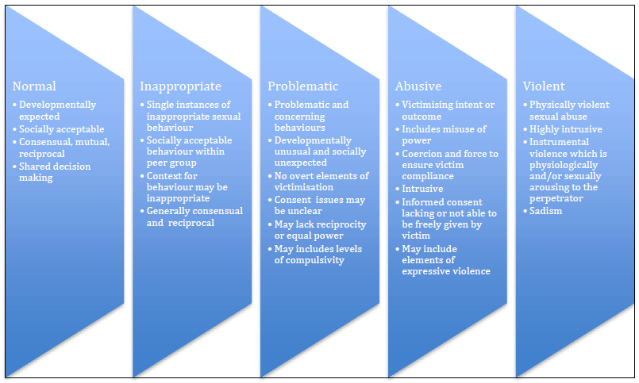
Harmful sexual behaviours:

Children’s sexual behaviours exist on a wide continuum, from normal and developmentally expected to inappropriate, problematic, abusive and violent. Harmful sexual behaviours refers to problematic, abusive and violent sexual behaviours which are developmentally inappropriate and may cause developmental damage. For more information see NSPCC Harmful Sexual Behaviours
When considering harmful sexual behaviours, ages and the stages of development of the children are critical factors to consider. Sexual behaviour between children can be considered harmful if one of the children is much older, particularly if there is more than two years’ difference in age, or if one of the children is pre-pubescent and the other is not. However, a younger child can abuse an older child, particularly if they have power over them, for example, if the older child is disabled or smaller in stature. A useful tool is: Beyond Referrals Toolkit
Harmful sexual behaviours will be considered in a child protection context.
The Queen Anne recognises that pupils displaying harmful sexual behaviours have often experienced their own abuse and trauma and they will be offered appropriate support.

The Queen Anne has a clear set of values and standards , and these will be upheld and demonstrated throughout all aspects of school life. The school has a Behaviour Policy and Anti-Bullying Policy
The PSHE and RSE curriculum covers the following issues according to the age and stage of development of the pupils:
- healthy and respectful relationships
- what respectful behaviour looks like
- gender roles, stereotyping, equality
- body confidence and self-esteem
- prejudiced behaviour
- that sexual violence and sexual harassment is always wrong
- addressing cultures of sexual harassment
- consent

Responding to allegations of sexual harassment and sexual violence
Pupils in our school know how to report concerns using class-based Worry Boxes. All reports are treated seriously, including those that occur online or out of school.
wi The Queen Anne ll make decisions on a case-by-case basis, with the DSL (or a deputy) taking a leading role and using their professional judgement, supported by other agencies, such as children’s social care and the police as required. When to call the police

The management of children and young people with sexually harmful behaviour is complex and The Queen Anne will work with other relevant agencies to maintain the safety of the whole school community. Where appropriate, immediate measures will be put in place to support and protect both the victim and the alleged perpetrator. A written record will be made and next steps discussed, taking into account the views of the victim.

A risk and needs assessment will be completed for all reports of sexual violence. The need for a risk and needs assessment for reports of sexual harassment will be considered on a case by case basis. The assessment, which will be kept under review, will consider:
- whether there may have been other victims
- the victim, especially their protection and support
- the alleged perpetrator
- all the other children (and, if appropriate, adult students and staff) at The Queen Anne, especially any actions that are appropriate to protect them from the alleged perpetrator or from future harm.

The Queen Anne will ensure that appropriate measures are put in place to safeguard and support the victim, the alleged perpetrator and the school community.
Useful links: Stop it Now Beyond Referrals

Unsubstantiated, unfounded, false or malicious reports
If a report is determined to be unsubstantiated, unfounded, false or malicious, the DSL will consider whether the pupil and/or the person who has made the allegation is in need of help, or may have been abused by someone else and this is a cry for help. In such circumstances, a referral to children’s social care may be appropriate.
If a report is shown to be deliberately invented or malicious, we will consider whether any disciplinary action is appropriate against the individual according to our Behaviour Policy.

Upskirting
The Queen Anne will ensure that all staff and pupils are aware of the changes to the Voyeurism (Offences) Act 2019 which criminalise the act of 'upskirting'. The Criminal Prosecution Service (CPS) defines 'upskirting' as: “a colloquial term referring to the action of placing equipment such as a camera or mobile phone beneath a person’s clothing to take a voyeuristic photograph without their permission. It is not only confined to victims wearing skirts or dresses and equally applies when men or women are wearing kilts, cassocks, shorts or trousers. It is often performed in crowded public places, for example on public transport or at music festivals, which can make it difficult to notice offenders.”
Incidents of upskirting in the school will not be tolerated. The Queen Anne will make decisions on a case-by-case basis, with the DSL (or a deputy) taking a leading role and using their professional judgement, supported by other agencies, such as children’s social care and the police as required.

Sharing nudes and semi-nudes
The Queen Anne will act in accordance with guidance endorsed by DfE Sharing nudes and semi-nudes: how to respond to an incident
All incidents of sharing nudes and semi-nudes will be dealt with as safeguarding concerns. The primary concern at all times will be the welfare and protection of the young people involved.
Young people who share nudes and semi-nudes of themselves or their peers are breaking the law. However, as highlighted in national guidance, it is important to avoid criminalising young people unnecessarily. The Queen Anne will therefore work in partnership with external agencies with a view to responding proportionately to the circumstances of any incident.
All incidents of sharing nudes and semi-nudes should be reported to the DSL as with all other safeguarding issues and concerns. Staff will not make their own judgements about whether an issue relating to sharing nudes and semi-nudes is more or less serious enough to warrant a report to the DSL. What may seem like less serious concerns to individual members of staff may be more significant when considered in the light of other information known to the DSL, which the member of staff may not be aware of.
If staff become concerned about a sharing nudes and semi-nudes issue in relation to a device in the possession of a student (e.g. mobile phone, tablet, digital camera), the member of staff will secure the device (it should be confiscated). This is consistent with DfE advice "Searching, screening and confiscation: advice for headteachers, school staff and governing bodies" (DfE January 2018), page 11 'After the search'. Searching, screening and confiscation
Staff will not look at, share or print any indecent images. The confiscated device will be passed immediately to the DSL (see ‘Viewing the imagery’ below).
The DSL will discuss the concerns with appropriate staff and speak to young people involved as appropriate. Parents and carers will be informed at an early stage and involved in the process unless there is good reason to believe that involving parents would put the young person at risk of harm.
If, at any point in the process, there is concern that a young person has been harmed or is at risk of harm, a referral will be made to SPA and/or the police immediately.
The police will always be informed when there is reason to believe that indecent images involve sexual acts and any child in the imagery is under 13 years of age.
The DSL will make a judgement about whether a reported sharing nudes and semi-nudes incident is experimental or aggravated. Aggravated incidents involve criminal or abusive elements beyond the creation, sending or possession of sexual images created by young people. These include possible adult involvement or criminal or abusive behaviour by young people such as sexual abuse, extortion, threats, malicious conduct arising from personal conflicts, or creation, sending or showing of images without the knowledge or against the will of a young person who is pictured.
Aggravated incidents of sharing nudes and semi-nudes will be referred to AfC’s Single Point of Access for advice about whether or not a response by the police and/or children's social care is required.
This will facilitate consideration of whether:
- there are any offences that warrant a police investigation
- child protection procedures need to be invoked
- parents and carers require support in order to safeguard their children
- any of the perpetrators and/or victims require additional support, this may require the initiation of an Family Help assessment and the offer of Family Help services.

Examples of aggravated incidents include:
• evidence of adult involvement in acquiring, creating or disseminating indecent images of young people (possibly by an adult pretending to be a young person known to the victim)
- evidence of coercing, intimidating, bullying, threatening and/or extortion of students by one or more other students to create and share indecent images of themselves
- pressure applied to a number of students (e.g. all female students in a class or year group) to create and share indecent images of themselves
- pressurising a student who does not have the capacity to consent (e.g. due to their age, level of understanding or special educational needs) or with additional vulnerability to create and share indecent images of themselves
- dissemination of indecent images of young people to a significant number of others with an intention to cause harm or distress (possibly as an act of so-called 'revenge porn', bullying or exploitation)
- what is known about the imagery suggests the content depicts sexual acts that are unusual for the young person’s developmental stage or are violent
- sharing of indecent images places a young person at immediate risk of harm, for example the young person is presenting as suicidal or self-harming.
The DSL will make a judgement about whether or not a situation in which nudes and semi-nudes have been shared with a small number of others in a known friendship group with no previous concerns constitutes an aggravated incident or whether the school is able to contain the situation in partnership with all parents of the students involved, arrange for the parents to ensure that all indecent images are deleted and that the young people involved learn from the incident in order to keep themselves safe in future.

In the latter instance, the DSL will consult with the police and the SPA to check that no other relevant information is held by those agencies and to ensure an agreed response is documented before proceeding.

Viewing the imagery
Adults should not view nudes and semi-nudes unless there is a good and clear reason to do so. Wherever possible, the DSL’s responses to incidents will be based on what they have been told about the content of the imagery.

Any decision to view imagery will be based on the DSL’s professional judgement. Imagery will never be viewed if the act of viewing will cause significant distress or harm to a pupil.
If a decision is made to view imagery, the DSL will be satisfied that viewing:
- is the only way to make a decision about whether to involve other agencies (it is not possible to establish the facts from the young people involved)
- is necessary to report the image to a website, app or suitable reporting agency to have it taken down, or to support the young person or parent in making a report
- is unavoidable because a young person has presented an image directly to a staff member or the imagery has been found on a school device or network.
If it is necessary to view the imagery then the DSL will:
- never copy, print or share the imagery; this is illegal
- discuss the decision with the headteacher
- ensure viewing is undertaken by the DSL or deputy DSL with delegated authority from the headteacher
- ensure viewing takes place with another member of staff present in the room, ideally the head teacher, another DSL or a member of the Senior Leadership Team. The other staff member does not need to view the images
- wherever possible ensure viewing takes place on school premises, ideally in the headteacher’s or DSL’s office
- ensure wherever possible that images are viewed by a staff member of the same sex as the young person in the imagery
- record the viewing of the imagery in the pupil’s safeguarding record, including who was present, why the image was viewed and any subsequent actions; and ensure this is signed and dated and meets the wider standards set out by Ofsted for recording safeguarding incidents.

Deletion of images
If the school has decided that other agencies do not need to be involved, then consideration will be given to deleting imagery from devices and online services to limit any further sharing of the imagery.

Cybercrime
Cybercrime is criminal activity committed using computers and/or the internet. It is broadly categorised as either ‘cyber-enabled’ (crimes that can happen off-line but are enabled at scale and at speed on-line) or ‘cyber-dependent’ (crimes that can be committed only by using a computer). Cyber-dependent crimes include
- unauthorised access to computers (illegal ‘hacking’), for example accessing a school’s computer network to look for test paper answers or change grades awarded
- denial of service (DoS or DDoS) attacks or ‘booting’. These are attempts to make a computer, network or website unavailable by overwhelming it with internet traffic from multiple sources
- making, supplying or obtaining malware (malicious software) such as viruses, spyware, ransomware, botnets and Remote Access Trojans with the intent to commit further offences, including those above.

Children with particular skill and interest in computing and technology may inadvertently or deliberately stray into cyber-dependent crime.
If there are concerns about a pupil in this area, the DSL (or a deputy) will consider referring into the Cyber Choices programme. This is a nationwide police programme supported by the Home Office and led by the National Crime Agency, working with regional and local policing. It aims to intervene where young people are at risk of committing, or being drawn into, low level cyber-dependent offences and divert them to a more positive use of their skills and interests.
Note that Cyber Choices does not currently cover ‘cyber-enabled’ crime such as fraud, purchasing of illegal drugs online and child sexual abuse and exploitation, nor other areas of concern such as online bullying or general online safety. Additional advice can be found at: National Cyber Security Centre When to call the police

Online safety
The Queen Anne has a whole school approach to online safety, which protects and educates pupils and staff in their use of technology and establishes mechanisms to identify, intervene in, and escalate any concerns where appropriate.
Online safety is reflected as required in all relevant policies and is considered when planning the curriculum in all subjects.
Children and young people commonly use electronic equipment including mobile phones, tablets and computers on a daily basis to access the internet and share content and images via social networking sites such as Facebook, TikTok, Twitter, MSN, Tumblr, Snapchat, Instagram and gaming platforms.
Those technologies and the internet are a source of fun, entertainment, communication and education. Unfortunately, however, some adults and young people will use those technologies to harm children. That harm might range from sending hurtful or abusive texts and emails to grooming and enticing children to engage in sexually harmful conversations, webcam photography or face-to-face meetings. Pupils may also be distressed or harmed by accessing inappropriate websites that promote unhealthy lifestyles, extremist behaviour and criminal activity.
Chatrooms and social networking sites are the more obvious sources of inappropriate and harmful behaviour and pupils are not allowed to access those sites in school. Many pupils own or have access to handheld devices and parents are encouraged to consider measures to keep their children safe when using the internet and social media at home and in the community.
The Queen Anne’s online safety policy explains how we try to keep pupils safe in school and protect and educate pupils in the safe use of technology. The Queen Anne follows the DfE guidance regarding teaching online safety in schools (2019) Teaching online safety in schools
Online bullying and sharing nudes and semi-nudes by pupils will be treated as seriously as any other type of bullying and will be managed through our anti-bullying procedures (see ‘Sharing nudes and semi-nudes’ below).
AI, filtering and monitoring
The Queen Anne refers to the guidance on generative AI: product safety expectations and Filtering and monitoring standards for schools and colleges to use AI safely and to help us understand the filtering and monitoring requirements around AI.

So-called ‘honour based’ abuse
So-called ‘honour based’ abuse (HBA) can be described as a collection of practices, which are used to control behaviour within families or other social groups to protect perceived cultural and religious beliefs and/or honour. Such abuse can occur when perpetrators perceive that a relative has shamed the family and/or community by breaking their honour code. Crimes include female genital mutilation (FGM), forced marriage and harmful practices such as breast ironing.
Honour based abuse might be committed against young people in our school who
- become involved with a boyfriend or girlfriend from a different culture or religion
- want to avoid an arranged marriage
- want to avoid a forced marriage
- wear clothes or take part in activities that might not be considered traditional within a particular culture.
It is a violation of human rights and may be a form of domestic and/or sexual abuse. There is no, and cannot be, honour in or justification for abusing the human rights of others. Staff at The Queen Anne will record and report any concerns about a child who might be at risk of HBA to the DSL as with any other safeguarding concern. The DSL will consider the need to make a referral to the police and/or the SPA as with any other child protection concern and may also contact the forced marriage unit for advice as necessary.

Female genital mutilation (FGM)
Female genital mutilation (FGM) is a form of child abuse. It is the collective name given to a range of procedures involving the partial or total removal of the external female genitalia for non-medical reasons or other injury to the female genital organs. It has no health benefits and harms girls and women in many ways. The practice, which is most commonly carried out without anaesthetic, can cause intense pain and distress and long-term health consequences, including difficulties in childbirth.

FGM is carried out on girls of any age, from young babies to older teenagers and adult women, so school staff are trained to be aware of risk indicators.
These risk indicators may include:
- pupil talking about getting ready for a special ceremony
- family taking a long trip abroad
- pupil’s family being from one of the ‘at risk’ communities for FGM (Kenya, Somalia, Sudan, Sierra Leone, Gambia, Egypt, Nigeria, Eritrea as well as non-African communities including Yemeni, Afghani, Kurdish, Indonesian and Pakistani)
- knowledge that the pupil’s sibling has undergone FGM
- pupil talking about going abroad to be ‘cut’ or to prepare for marriage
Many such procedures are carried out abroad and staff will be particularly alert to suspicions or concerns expressed by female pupils about going on a long holiday during the summer holiday period. Staff are aware that it is also possible for these procedures to be undertaken in the UK.
In England, Wales and Northern Ireland, the practice is illegal under the Female Genital Mutilation Act 2003. Any person found guilty of an offence under the Female Genital Mutilation Act 2003 is liable to a maximum penalty of 14 years imprisonment or a fine, or both.
(See Female Genital Mutilation Statutory Guidance for further information)
If staff have a concern that a girl may be at risk of FGM, they will record their concern and inform the DSL as they would any other safeguarding concern.

Signs that may indicate a pupil has undergone FGM:
- prolonged absence from school and other activities
- behaviour change on return from a holiday abroad, such as being withdrawn and appearing subdued
- bladder or menstrual problems
- finding it difficult to sit still and looking uncomfortable
- complaining about pain between the legs
- mentioning something somebody did to them that they are not allowed to talk about
- secretive behaviour, including isolating themselves from the group
- reluctance to take part in physical activity
- repeated urinary tract infection
- disclosure
Teachers are subject to a statutory duty defined by Section 5B of the Female Genital Mutilation Act 2003 (as inserted by section 74 of the Serious Crime Act 2015) to report to the police personally where they discover (e.g. by means of a disclosure) that an act of FGM appears to have been carried out on a girl who is aged under 18. This is known as mandatory reporting.
The mandatory reporting duty applies to all persons in The Queen Anne who are employed or engaged to carry out ‘teaching work’ in the school, whether or not they have qualified teacher status. The duty applies to the individual who becomes aware of the case to make a report to the police.
In The Queen Anne, teachers in this situation will record their concerns in writing and inform the DSL, who will support the teacher in making a direct report to the police.
There are no circumstances in which a teacher or other member of staff will examine a girl.

Forced marriage
A forced marriage is a marriage in which a female (and sometimes a male) does not consent to the marriage but is coerced into it. Coercion may include physical, psychological, financial, sexual and emotional pressure. It may also involve physical or sexual violence and abuse.

A forced marriage is not the same as an arranged marriage. In an arranged marriage, which is common in several cultures, the families of both spouses take a leading role in arranging the marriage but the choice of whether or not to accept the arrangement remains with the prospective spouses.

Children may be married at a very young age, and well below the age of consent in England. School staff should be particularly alert to suspicions or concerns raised by a pupil about being taken abroad and not being allowed to return to England.

Since June 2014, forcing someone to marry has become a criminal offence in England and Wales under the Anti-Social Behaviour, Crime and Policing Act 2014.
For further information see: Guidance forced marriage

School staff will never attempt to intervene directly as a school or through a third party. Contact will be made with the Single Point of Access.
Asian Women's Resource Centre

Child trafficking and modern slavery
Human trafficking, is defined in the UN Protocol on trafficking, adopted in 2000, as the acquisition of a person, by means of deception or coercion, for the purposes of exploitation. Human trafficking, or modern slavery as it is often referred to, is a crime and a safeguarding issue affecting millions across the world and in the United Kingdom.
Staff at The Queen Anne are alert to the existence of modern slavery and child trafficking and concerns will be recorded and reported to SPA as appropriate.

Types of Modern Slavery
Examples of industries and services where slavery exist in the UK today, the victims of which include children and young people are (with examples)
- the sex industry, including brothels
- retail: nail bars, hand car washes
- factories: food packing
- hospitality: fast-food outlets
- agriculture: fruit picking
- domestic labour: cooking, cleaning and childminding
- In addition, victims can be forced into criminal activities such as cannabis production, theft or begging.
Modern slavery is an issue that transcends age, gender and ethnicities. It can include victims that have been brought to the UK from overseas or vulnerable people in the UK being forced illegally to work against their will. Children and young people have an increased vulnerability to slavery.
Poverty, limited opportunities at home, lack of education, unstable social and political conditions and war are some of the situations that contribute to trafficking of victims and slavery.
Slavery can be linked to a number of safeguarding issues, including child sexual exploitation, but normally includes at least one of the following specific situations.
- Child trafficking: young people being moved internationally or domestically so that they can be exploited.
- Forced labour: victims are forced to work through physical or mental threat, against their will, often for very long hours for little or no pay, in conditions that can affect their physical and mental health. They are often subjected to verbal or physical threats of violence against them as individuals or their families.
- Debt bondage: victims forced to work to pay off debts that they will never be able to. Debts can be passed down to children. Extreme examples include where a victim may be owned or controlled by an ‘employer’ or sold as a commodity.
Possible signs and indicators that someone is a victim of modern slavery that anyone working with children and young people should be aware of include:
- physical appearance: poor physical condition, malnourishment, untreated injuries and looking neglected
- isolation: victims may not be allowed out on their own and may appear to be under the control or influence of people accompanying them, with the absence of a parent or legal guardian. They may not interact and be unfamiliar in their local community
- poor living conditions: victims may be living in dirty, cramped or overcrowded accommodation, with multiple children living and working at the same address or premises
- personal belongings: few possessions, wearing the same clothes each day and no identification documents
- restricted freedom: victims have little opportunity to move freely and may be kept from having access to their passport
- unusual travel times: victims may be dropped off or collected from work on a regular basis either very early or late at night
- reluctant to seek help: victims may avoid eye contact, appear frightened or hesitant to approach people and have lack of trust or concern about making a report should they be deportation or fear of violence on their family
If a member of The Queen Anne staff suspects that a pupil may be a victim they will, in the first instance, report their concerns to the DSL.
The DSL will seek advice and support from SPA who may in turn make a referral to the National Crime Agency via the National Referral Mechanism (NRM).
Further advice can be provided directly by the modern slavery helpline on 0800 012 1700.
Modern slavery: how to identify and support victims

Private fostering
A private fostering arrangement occurs when someone other than a parent or a close relative cares for a child for a period of 28 days or more, with the agreement of the child’s parents. Close relatives are defined as step parents, grandparents, brothers, sisters, uncles or aunts. It applies to children under the age of 16, or under 18 if the child is disabled. Children looked after by the local authority or who are placed in a residential school, children’s home or hospital are not considered to be privately fostered.
Private fostering occurs in all cultures, including British culture and children may be privately fostered at any age.
The Queen Anne recognises that most privately fostered children remain safe and well, but safeguarding concerns have been raised in some cases. Therefore, all staff are alert to possible safeguarding issues, including the possibility that a child has been trafficked into the country.
By law, a parent, private foster carer or other persons involved in making a private fostering arrangement must notify Children’s Social Care as soon as possible. When The Queen Anne becomes aware of a private fostering arrangement for a pupil that has not been notified to Children’s Social Care, we will encourage parents and private foster carers to notify Children’s Social Care themselves in the first instance, but also alert them to our mandatory duty as a school to inform the local authority of children in such arrangements.
Looking after someone else's child

Radicalisation and extremism
Protecting children from the risk of radicalisation is part of The Queen Anne’s wider safeguarding duties and is similar in nature to protecting children from other forms of harm and abuse.
Section 26 of the Counter-Terrorism and Security Act 2015 places a duty on education and other children’s services (‘specified authorities’) to have ‘due regard to the need to prevent people from being drawn into terrorism’.
Radicalisation refers to the process by which a person comes to support terrorism and forms of extremism. The government defines extremism as vocal or active opposition to fundamental British values.
The Queen Anne seeks to protect children and young people against the messages of all violent extremism including, but not restricted to, those linked to Islamist ideology, or to far right/neo-Nazi/white supremacist ideology, Irish Nationalist and Loyalist paramilitary groups, and extremist animal rights movements.
Even very young children have been exposed, in rare circumstances, to extremism at home and elsewhere including online.
As children get older, they look for adventure and excitement and they may start to ask questions about their identity and belonging. During this stage of their development they are vulnerable to extremist groups that may claim to offer answers, identity and a social network apparently providing a sense of belonging. Many of those extremist groups make sophisticated use of the internet and social media to target young people and spread their ideology, making young people more vulnerable to being influenced by extremist ideas.
The Queen Anne takes seriously our responsibility to ensure that children are safe from terrorist and extremist material when accessing the internet in school.
During the process of radicalisation it is possible to intervene to prevent vulnerable people being radicalised. The Queen Anne is committed to preventing pupils from being radicalised and drawn into any form of extremism or terrorism. The Queen Anne promotes the values of democracy, the rule of law, individual liberty, mutual respect and tolerance of those with different faiths and beliefs by providing pupils with opportunities through the curriculum to discuss issues of religion, ethnicity and culture and learn how to discuss and debate points of view; and by ensuring that all pupils are valued and listened to within school.

The Queen Anne staff receive training that provides them with both the information they need to understand the risks affecting children and young people in this area and a specific understanding of how to identify and support individual children who may be at risk of radicalisation. Staff are trained to report all concerns about possible radicalisation and extremism to the DSL immediately as they would any other safeguarding concern.
The Queen Anne recognises the importance of providing a safe space for children to discuss controversial issues and build the resilience and critical thinking skills needed to challenge extremist perspectives.
When any member of staff has concerns that a pupil may be at risk of radicalisation or involvement in terrorism, they will speak with the DSL.
The Queen Anne will discuss any concerns about possible radicalisation identified in school with a pupil’s parents and carers as with any other safeguarding or child protection issue unless there is reason to believe that doing so would place the child at risk. They will also support parents and carers who raise concerns about their children being vulnerable to radicalisation.
We will then follow normal safeguarding procedures, which may involve contacting the Single Point of Access for consultation and further advice and/or making appropriate referrals to the police PREVENT team and Channel programme for any pupil whose behaviour or comments suggest that they are vulnerable to being radicalised and drawn into extremism and terrorism in order to ensure that children receive appropriate support.
The Department for Education has also set up a dedicated telephone helpline for staff and governors to raise concerns around Prevent (020 7340 7264).
We expect all staff, volunteers, governors, visiting professionals, contractors and individuals or agencies that hire school premises to behave in accordance with the school’s staff behaviour policy (code of conduct) . We will challenge the expression and/or promotion of extremist views and ideas by any adult on school premises or at school events and, when necessary, will make appropriate referrals in respect of any such adult.
Parents and staff may find the following websites informative and useful:
Protecting children from radicalisation: the prevent duty
Educate against hate

Suicide and self-harm
Suicide: an act of deliberate self-harm which results in death.
Self-harm: self-poisoning or self-injury, irrespective of the apparent purpose of the act.
Suicide and self-harm links: self-harm is generally a way of coping with overwhelming emotional distress. Many young people self-harm where there is no suicidal intent. However, research shows that young people who self-harm can be at a higher risk of suicide.

Self-harm is a coping mechanism that enables a person to express difficult emotions. Young people who hurt themselves often feel that physical pain is easier to deal with than the emotional pain they are experiencing, because it is tangible. But the behaviour only provides temporary relief and fails to deal with the underlying issues that a young person is facing. For some people, self-harm may last for a short time. For others, it can become a long-term problem. Some people self-harm, stop for a while, and return to it months, even years, later, in times of distress.

Risk factors that indicate a child or young person may be at risk of taking actions to harm themselves or attempt suicide can cover a wide range of life events such as bereavement; bullying; online bullying; mental health problems including eating disorders; family problems such as domestic violence; or any form of abuse or conflict between the child and parents.

The most common forms of self-harm are
- cutting
- biting self
- burning, scalding, branding
- picking at skin, reopening old wounds
- breaking bones, punching
- hair pulling
- head banging
- ingesting objects or toxic substances
- overdosing with a medicine

Self-harm is usually a secretive behaviour but signs may include:
- wearing long sleeves at inappropriate times
- spending more time in the bathroom
- unexplained cuts or bruises, burns or other injuries
- unexplained smell of Dettol, TCP, etc.
- low mood - seems to be depressed or unhappy, low self-esteem, feelings of worthlessness
- any mood changes - anger, sadness
- changes in eating or sleeping patterns
- losing friendships, spending more time by themselves and becoming more private or defensive
- withdrawal from activities that used to be enjoyed
- abuse of alcohol and/or drugs
The Queen Anne recognises that any pupil who self-harms or expresses thoughts about self-harm and/or suicide must be taken seriously and appropriate help and intervention will be offered at the earliest point. Any member of staff who is made aware that a pupil has self-harmed, or is contemplating self-harm or suicide, will record and report the matter to the DSL as soon as possible as with any other safeguarding concern.
A safety plan will be developed for any pupil at risk of suicide.

Fabricated or induced illnesses
Staff at The Queen Anne are alert to the issues surrounding fabricated or induced illnesses.
Fabricated or induced illness (FII) is a rare form of child abuse. It happens when a parent or carer, usually the child's biological mother, exaggerates or deliberately causes symptoms of illness in the child.
There are many ways that the parent/carer may fabricate (make up or lie about) or induce illness in a child:
- lying about their child's symptoms
- deliberately contaminating or manipulating clinical tests to fake evidence of illness. For example, by adding blood or glucose to urine samples, placing their blood on the child's clothing to suggest unusual bleeding, or heating thermometers to suggest the presence of a fever
- poisoning their child with unsuitable and non-prescribed medicine
- infecting their child’s wounds or injecting the child with dirt or poo
- inducing unconsciousness by suffocating their child
- not treating or mistreating genuine conditions so they get worse
- withholding food, resulting in the child failing to develop physically and mentally at the expected rate.
The very presence of an illness can act as a stimulus to the abnormal behaviour and also provide the parent with opportunities for inducing symptoms.
Fabricated or induced illness is most commonly identified in younger children. Although some of these children die, there are many that do not die as a result of having their illness fabricated or induced, but who suffer significant long term physical or psychological health consequences.
Fabrication of illness may not necessarily result in a child experiencing physical harm, but there may be concerns about the child suffering emotional harm. They may suffer emotional harm and/or disturbed family relationships as a result of an abnormal relationship with their parent.
Staff at The Queen Anne will record and report any concerns about a child who might be experiencing fabricated or induced illness to the DSL as with any other safeguarding concern. The DSL will consider the need to make a referral or consult with the Single Point of Access as with any other child protection concern.

The Royal College of Paediatrics and Child Health (RCPCH) has issued updated guidance: https://childprotection.rcpch.ac.uk/resources/perplexing-presentations-and-fii/

Child-Centred Safeguarding Practice
The school is committed to a child-centred approach to safeguarding, which focuses on listening to children’s lived experiences, building trusting and consistent relationships, and understanding each child within the context of their family and wider environment. The voice of the child is central to all safeguarding decisions and will be actively sought, recorded, and considered in all professional judgements and multi-agency discussions.
Staff are expected to ensure that the child’s voice is clearly recorded in all safeguarding records and to engage in ongoing relationship-based practice, rather than relying on one-off responses to concerns. This approach supports a deeper understanding of the child’s needs and ensures that safeguarding decisions are informed by the child’s lived experience and evolving circumstances.

Children who may be particularly vulnerable
Some children are more vulnerable to abuse, neglect or exploitation than others. Several factors may contribute to that increased vulnerability, including prejudice and discrimination; isolation; social exclusion; communication issues; a reluctance on the part of some adults to accept that abuse can occur; an individual child’s personality, behaviour, disability, mental and physical health needs; and family circumstances.
To ensure that all of our pupils receive equal protection, we will give special consideration to children who are:
- disabled or have special educational needs
- young carers
- affected by parental substance misuse, domestic abuse and violence or parental mental health needs
- asylum seekers
- looked after by the local authority or otherwise living away from home
- vulnerable to being bullied, or engaging in bullying behaviours
- living in temporary accommodation
- living transient lifestyles
- children with poor attendance
- living in chaotic and unsupportive home situations
- vulnerable to discrimination and maltreatment on the grounds of race, ethnicity, religion, disability or sexuality
- already perceived as a ‘problem’
- at risk of child sexual exploitation (CSE)
- do not have English as a first language
- at risk of female genital mutilation (FGM)
- at risk of forced marriage
- at risk of being drawn into extremism.

This list provides examples of vulnerable groups and is not exhaustive. Special consideration includes the provision of safeguarding information and resources in community languages and accessible formats for children with communication needs.

Children who have a social worker
Children may need a social worker due to safeguarding and/or welfare needs. This may be due to abuse, neglect or exploitation or complex family circumstances. The Queen Anne recognises that a child’s experiences of adversity and trauma can leave them vulnerable to further harm, as well as educationally disadvantaged in facing barriers to attendance, learning, behaviour and mental health.
The local authorities will share the fact that a child has a social worker with the school, and the DSL will ensure that decisions can be made in the best interests of the child’s safety, welfare and educational outcomes. This information will inform decisions about safeguarding (for example, responding to unauthorised absence or missing education where there are known safeguarding risks) and promoting welfare (for example, considering the provision of pastoral and/or academic support, alongside action by statutory services).
The role of the Virtual School has been extended to provide advice and support to children who are subject to a child in need plan or a child protection plan.

Children looked after and previously looked after
The most common reasons for children becoming looked after is as a result of abuse and/or neglect. The Queen Anne will ensure that staff have the necessary skills and knowledge to keep children looked after and previously looked after safe. Appropriate staff will have the information they need in relation to a child looked after’s legal status (for example, who has parental responsibility, who is not permitted to have contact and who is not permitted to know where the child is being educated) and the level of authority delegated by the caring authority to the carer.
The designated teacher for children looked after is Judith Street. The designated governor for children looked after is Carly Talbot.
The designated teacher will:
- promote a culture of high expectations and aspirations for how children looked after and previously looked after learn
- make sure the young person has a voice in setting learning targets
- be a source of advice for staff about differentiated teaching strategies appropriate for individual children and in making full use of Assessment for Learning
- make sure that the children are prioritised in one-to-one tuition arrangements and that carers understand the importance of supporting learning at home
- have lead responsibility for the development and implementation of all children looked after’s personal education plans (PEPs) within the school
- Virtual head have taken on extended duties to include Kinship Caring and attendance for children with a social worker
Role and responsibilities of the designated teacher
The designated teacher has attended appropriate training and ensures that the school has the up-to-date details of the allocated social worker/personal adviser (care leavers) and the virtual school headteacher in the local authority that looks after the child. Details of the AfC Virtual School can be found at: AfC Virtual School

Identified areas of particular risk for our school
- Situated close to Windsor Castle and Victoria Barracks which could present a significant risk.
- the playground and school grounds are in site of the public gaze
- the playground backs onto a public play park
- increasing number of children with Special Needs or those with English as an additional language
- Pre-school nursery uses the site on a weekly basis
- After-school clubs use the site weekly
- School trips accessing sports off-site
- Regular visits to the local church

Multi-agency working
The School’s Role in the Local Safeguarding Partnership
The school recognises its statutory responsibility to safeguard and promote the welfare of children and understands that this can only be achieved through effective multi-agency working. In line with Working Together to Safeguard Children 2026, the school is an active safeguarding partner within the local safeguarding arrangements.

Multi-Agency Working
The school will work collaboratively with safeguarding partners, including the local authority, police, and health services, to protect children from harm and promote their welfare. The school will actively contribute to the planning, delivery, and review of local safeguarding arrangements and priorities.

Information Sharing
The school recognises that timely, accurate, and appropriate information sharing is essential to effective safeguarding. Staff will share information with relevant agencies where there are concerns about a child’s welfare, in line with statutory guidance and data protection legislation. Concerns will not be withheld where this may place a child at risk of harm.

Contribution to Assessments and Plans
The school will play a full and active role in multi-agency safeguarding processes, including:
- Family Help (early intervention and targeted support)
- Child in Need (Section 17) assessments
- Child Protection (Section 47) enquiries
The school will provide relevant information, including attendance, behaviour, academic progress, and the voice of the child, to inform assessments and decision-making. Staff will support and implement agreed plans and interventions within the school setting.

Attendance at Multi-Agency Meetings
The Designated Safeguarding Lead (DSL), or an appropriate deputy, will ensure that the school is represented at all relevant multi-agency safeguarding meetings. This includes, but is not limited to:
- Strategy discussions
- Child protection conferences
- Core group meetings
The school will contribute effectively to these meetings and ensure that agreed actions are implemented and reviewed.

Early Identification and Family Help
The school recognises its key role in the early identification of need and risk. Staff will be vigilant in identifying concerns and will take appropriate action to provide support at the earliest opportunity. The school will initiate and contribute to Family Help processes and will work in partnership with families to prevent escalation of need wherever possible.

Professional Challenge and Escalation
The school is committed to ensuring that children receive effective and timely support. Where there are concerns that safeguarding partners are not taking appropriate action, the school will provide professional challenge and escalate concerns in line with local safeguarding procedures.

Contribution to Learning and Improvement
The school will contribute to the ongoing development and improvement of safeguarding practice by:
- Participating in safeguarding reviews and audits
- Providing relevant data and information to safeguarding partners
- Reflecting on practice and outcomes for children, including any disproportionality or discrimination

Responding to Local Safeguarding Priorities
The school will support and respond to local safeguarding partnership priorities. This includes ensuring that staff are appropriately trained and that safeguarding themes are reflected in the curriculum, policies, and practice.

FAMILY HELP
Family Help (early intervention and targeted support)
- At The Queen Anne we are prepared to identify children who may benefit from Family Help. Family Help means providing support as soon as a problem emerges at any point in a child’s life, from the foundation years through to teenage years. In the first instance staff should discuss Family Help requirements with the DSL. The school’s role is to initiating and contributing to Family Help plans as appropriate, in liaison with and maintaining a consistent relationship with the families.

Any child may benefit from family help, but at The Queen Anne we are particularly aware of the potential need for Family Help for a child who:
- is disabled and has specific additional needs
- has special educational needs (whether or not they have a statutory education, health and care plan)
- is a young carer
- is showing signs of being drawn in to antisocial or criminal behaviour, including gang involvement and association with organised crime groups
- is frequently missing/goes missing from education, home or care
- has experienced multiply suspensions, is at risk of being permanently excluded from schools, colleges and in Alternative Provision or PRU
- has a parent or carer in custody or is affected by parental offending
- is misusing drugs or alcohol themselves
- Is at risk of modern slavery, trafficking or exploitation
- is in a family circumstance presenting challenges for the child, such as substance abuse, adult mental health problems or domestic abuse
- has returned home to their family from care
- is showing early signs of abuse and/or neglect
- is at risk of being radicalised or exploited
- is a privately fostered child
- Has emerging challenging behaviours.
Hidden Harm
The school has consideration for specific needs, including, but not exclusive to, family members who may have learning difficulties/disabilities, are imprisoned or those whose first language is not English, parents, carers and children who may be at risk from hidden harms such as coercive and controlling behaviour, child sexual abuse and ‘honour’ or faith- or belief-based abuse, are care experienced, young parents, birth parents who have had children removed from their care, fathers or male carers, and parents who identify as LGBTQIA. This should also include where children may not view themselves as victims of abuse, such as teenage relationship abuse and child sexual exploitation.
The DSL can take a case to Family Help to get multi-agency support
If Family Help and/or other support is appropriate, the case will be kept under constant review and consideration given to a referral to children’s social care if the child’s situation doesn’t appear to be improving. The DSL is aware of the local escalation policy and procedures. We work closely with local professional agencies including social care, the police, health services and other services including voluntary organisations to promote the welfare of children and protect them from harm. This includes providing a co-ordinated offer of Family Help when additional needs of children are identified and contributing to inter-agency plans to provide additional support to children subject to child protection plans.
As part of meeting a child’s needs, our Governing Board recognises the importance of sharing information between professionals and local agencies. The Data Protection Act 2018 and GDPR do not prevent the sharing of information for the purposes of keeping children safe. Fears about sharing information must not be allowed to stand in the way of the need to safeguard and promote the welfare and protect the safety of children.
Family Help Strategy

What to do if staff are concerned about a child’s welfare
If staff have any concerns about a child’s welfare, they must act on them immediately. Any concerns regarding indicators of abuse or neglect or signs that a child may be experiencing a safeguarding issue should be recorded via CPOMS and passed to the DSL or Deputy DSL. For physical signs of abuse, a body map can also be used (appendix 3). Concerns can also be discussed in person with the DSL but the details of the concern should be recorded in writing.

There will be occasions when staff may suspect that a pupil may be at risk, but have no ‘real’ evidence. The pupil’s behaviour may have changed, their artwork could be bizarre, they may write stories or poetry that reveal confusion or distress, or physical or inconclusive signs may have been noticed.

The Queen Anne recognises that the signs may be due to a variety of factors, for example a parent has moved out, a pet has died, a grandparent is very ill or an accident has occurred. However, they may also indicate a child is being abused or is in need of safeguarding.
In these circumstances staff will exercise professional curiosity and will try to give the child the opportunity to talk. It is fine for staff to ask the pupil if they are OK or if they can help in any way.

Professional Curiosity
The school expects all staff to demonstrate professional curiosity in all safeguarding matters. In line with Working Together to Safeguard Children 2026, staff are expected to question, explore, and not accept information at face value where there are concerns about a child’s welfare. This includes being alert to patterns of behaviour, inconsistencies in explanations, and possible indicators of hidden harm.
Staff must demonstrate professional curiosity when concerns arise and take appropriate action to seek further information, share concerns with the Designated Safeguarding Lead, and contribute to a fuller understanding of the child’s circumstances. This approach ensures that potential risks are identified early and that safeguarding responses are based on a comprehensive understanding of the child’s lived experience.

Staff should use CPOMS to record these early concerns and give the completed form to the DSL.
Following an initial conversation with the pupil, if the member of staff remains concerned, they should discuss their concerns with the DSL and put them in writing.
If the pupil does begin to reveal that they are being harmed, staff should follow the advice below regarding a pupil making a disclosure.

What to do if a pupil discloses to a member of staff
Remember the seven Rs: receive; reassure; respond; report; record; remember; review (see appendix 5 for more details).

We recognise that it takes a lot of courage for a child to disclose they are being abused. They may feel ashamed, guilty or scared, their abuser may have threatened that something will happen if they tell, they may have lost all trust in adults or believe that what has happened is their fault. Sometimes they may not be aware that what is happening is abuse.
A child who makes a disclosure may have to tell their story on a number of subsequent occasions to the police and/or social workers. Therefore, it is vital that their first experience of talking to a trusted adult is a positive one.
For some extra help: NSPCC Responding to a child's disclosure of abuse
During their conversation with the pupil staff will:
- listen to what the child has to say and allow them to speak freely
- remain calm and not overact or act shocked or disgusted – the pupil may stop talking if they feel they are upsetting the listener
- reassure the child that it is not their fault and that they have done the right thing in telling someone
- not be afraid of silences – staff must remember how difficult it is for the pupil and allow them time to talk
- take what the child is disclosing seriously
- ask open questions and avoid asking leading questions
- avoid jumping to conclusions, speculation or make accusations
- not automatically offer any physical touch as comfort. It may be anything but comforting to a child who is being abused
- avoid admonishing the child for not disclosing sooner. Saying things such as ‘I do wish you had told me about it when it started’ may be the staff member’s way of being supportive, but may be interpreted by the child to mean they have done something wrong. There are multiple reasons why children delay disclosing
- tell the child what will happen next
If a pupil talks to any member of staff about any risks to their safety or wellbeing the staff member will let the child know that they will have to pass the information on. Staff are not allowed to keep secrets.
The member of staff should write up their conversation as soon as possible on CPOMS in the child’s own words. Staff should make this a matter of priority. The record should be signed and dated, the member of staff’s name should be printed and it should also detail where the disclosure was made and who else was present. For physical signs of abuse, a body map can also be used (appendix 3).The record should be handed to the DSL.

Notifying parents
The school will normally seek to discuss any concerns about a pupil with their parents. This must be handled sensitively and the DSL will make contact with the parent in the event of a concern, suspicion or disclosure.
However, if the school believes that notifying parents could increase the risk to the child or exacerbate the problem, advice will first be sought from the Single Point of Access.
Where there are concerns about forced marriage, honour based abuse or any harmful practice, parents should not be informed a referral is being made as to do so may place the child at a significantly increased risk.

Making a referral to the Single Point of Access (SPA)
Concerns about a pupil or a disclosure should be discussed with the DSL who will help decide whether a referral to the Single Point of Access is appropriate. If a referral is needed then the DSL should make it. However, anyone, including children, can make a referral and if for any reason a staff member thinks a referral is appropriate and one hasn’t been made, they can and should consider making a referral themselves.
The pupil (subject to their age and understanding) and the parents will be told that a referral is being made, unless to do so would increase the risk to the pupil.
If you have not had any feedback from SPA within 72 hours of making the referral, you must follow this up.
If after a referral the pupil’s situation does not appear to be improving, the DSL (or whoever made the referral) should press for re-consideration to ensure their concerns have been addressed, and most importantly the pupil’s situation improves.
If a pupil is in immediate danger or is at risk of harm, a referral should be made to SPA and/or the police immediately. Anybody can make a referral.
Where referrals are not made by the DSL, the DSL should be informed as soon as possible.
SPA: 01628 683150
OUT OF HOURS: 01344 786543
SPA referral form

Child Protection Processes and Multi-Agency Safeguarding Partnerships
The school recognises the strengthened expectations within Working Together to Safeguard Children 2026 regarding child protection processes and the importance of effective multi-agency working. known as multi-agency safeguarding arrangements (MASAs).
Where there are concerns that a child may be at risk of significant harm, the school will contribute fully to Section 47 enquiries, including strategy discussions, multi-agency assessments, and direct engagement with the child where appropriate.
The school will ensure that it provides relevant, timely, and accurate information to support decision-making and safeguarding planning. This includes contributing evidence relating to attendance, behaviour, wellbeing, and the child’s lived experience, and actively participating in strategy meetings, child protection conferences, and other multi-agency safeguarding processes. The school will also ensure that agreed actions are followed up and implemented effectively within the school setting.
Where safeguarding concerns are not being appropriately progressed or addressed, the school will follow local escalation procedures to ensure that risks to the child are not overlooked or left unresolved.
The school recognises its role as an active safeguarding partner within local safeguarding arrangements. It is committed to early identification of need and risk, and to working collaboratively with partner agencies to protect and promote the welfare of children. The school will contribute to multi-agency working at all levels, ensuring that children receive timely and coordinated support and intervention.

Support for staff
We recognise that staff working in the school who have become involved with a child who has suffered harm, or appears to be likely to suffer harm, may find the situation stressful and upsetting.
We will support such staff by providing an opportunity to talk through their anxieties with the DSLs and to seek further support as appropriate.

Confidentiality
The Queen Anne recognises that to effectively meet a child’s needs, safeguard their welfare and protect them from harm, the school must contribute to inter-agency working in line with Working Together to Safeguard Children 2026 and share information between professionals and agencies where there are concerns.
All staff must be aware that they have a professional responsibility to share information with other agencies in order to safeguard children and that the Data Protection Act 2018 and GDPR is not a barrier to sharing information where the failure to do so would place a child at risk of harm.
The DfE emphasises that: “The Data Protection Act 2018 and GDPR do not prevent, or limit, the sharing of information for the purposes of keeping children safe. Fears about sharing information must not be allowed to stand in the way of the need to promote the welfare and protect the safety of children.”
All staff must be aware that they cannot promise a pupil to keep secrets which might compromise the pupil’s safety or wellbeing. It is important that staff and volunteers tell the pupil in a manner appropriate to the pupil’s age and development that they cannot promise complete confidentiality and that they may need to pass information on to other professionals to help to keep the pupil or other children safe.
However, we also recognise that all matters relating to child protection are personal to children and families. Therefore, in this respect they are confidential and the headteacher or DSLs will only disclose information about a pupil to other members of staff on a need to know basis.
We will always undertake to share our intention to refer a child to SPA with their parents and carers unless to do so could put the pupil at greater risk of harm, or impede a criminal investigation. If in doubt, we will consult with SPA on this point.

Record Keeping
Pupils’ safeguarding and child protection records will be stored securely and access to them will be appropriately limited.
When pupils leave The Queen Anne , the school will ensure that their child protection file is transferred to the new school or college as soon as possible. This will be transferred separately from their main pupil file, ensuring secure transit and a confirmation of receipt will be requested and retained. Where appropriate, the DSL will share information in advance of the pupil transferring so support can be put in place.
If The Queen Anne is the last school that the pupil attends, their child protection file will be securely stored by the school until their 26th birthday is reached, when it will be securely disposed of.

Safeguarding Accountability, Monitoring and Impact
The school recognises that effective safeguarding is not only demonstrated through the existence of systems and procedures, but through the positive impact these have on outcomes for children. In line with Working Together to Safeguard Children 2026, the school is committed to evaluating the effectiveness of its safeguarding practice and ensuring that it leads to meaningful improvements in children’s safety, wellbeing, and lived experiences.
The Designated Safeguarding Lead (DSL) will undertake regular monitoring and evaluation of safeguarding activity, identifying patterns, themes, and areas for development. The DSL will provide reports to the governing body that focus not only on quantitative data, such as referrals and case numbers, but also on qualitative impact, including how effectively risks are being reduced and how well children’s needs are being met. Governors will use this information to hold the school to account for safeguarding effectiveness and to ensure continuous improvement in practice

Procedure for dealing with complaints and allegations about staff
The Queen Anne has a whole school approach to safeguarding and we promote an open and transparent culture in which all concerns about all adults working in or on behalf of the school (including supply teachers, volunteers and contractors) are dealt with promptly and appropriately.
Despite all efforts to recruit safely, there may be occasions when allegations of abuse against children are reported to have been committed by staff, supply staff, practitioners, other outsider organisations and/or volunteers, who work with pupils in our school.
An allegation is any information which indicates that a member of staff, supply staff or volunteer or other outsider organisations may have:
- behaved in a way that has harmed a child, or may have harmed a child
- possibly committed a criminal offence against or related to a child
- behaved towards a child or children in a way that indicates he or she may pose a risk of harm to children
- behaved or may have behaved in a way that indicates they may not be suitable to work with children.
This applies to any child the member of staff, supply staff or volunteer or other outsider organisations that has contact with in their personal, professional or community life, as if they had child protection concerns raised for their own children.
To reduce the risk of allegations, all staff should be aware of safer working practice and should be familiar with the guidance contained in the staff handbook, school’s code of conduct and the ‘Guidance for safer working practice for adults who work with children and young people in education settings’
Guidance for safer working practice 2019
Guidance for safer working practice addendum April 2020
Guidance about conduct and safe practice, including safe use of mobile phones by staff, will also be given at induction.
All staff should be aware of The Queen Anne’s Behaviour policy.
All school staff should take care not to place themselves in a vulnerable position with a pupil. It is always advisable for interviews or work with individual pupils or parents to be conducted in view of other adults.
We understand that a pupil may make an allegation against a member of staff or staff may have concerns about another staff member. If such an allegation is made, or information is received which suggests that a person may be unsuitable to work with children, the member of staff receiving the allegation or aware of the information, will immediately inform the headteacher or the DSL.
The headteacher or the DSL on all such occasions will discuss the content of the allegation with the local authority designated officer (LADO) within 24 hours and before taking any further action.
If the allegation made to a member of staff concerns the headteacher, the person receiving the allegation will immediately inform the chair of governors who will consult the LADO as above, without notifying the headteacher first. Contact details for the chair of governors can be found in section 2 of this policy.
Reporting to the LADO applies even where the nature of the alleged assault would not normally meet the threshold if applied to children in their own families. For example, a report of a child being smacked by a parent, with no injury caused, would be unlikely to require any response by police or Children’s Social Care. However, a similar report of a child being smacked by a teacher should be responded to because of:
- the vulnerability of children away from home
- the higher standards of conduct demanded by law and regulation of those caring for other people’s children
- the position of trust enjoyed by such people
The Queen Anne will follow Keeping Children Safe in Education 2025 for managing allegations against staff and procedures.
Suspension of the member of staff, against whom an allegation has been made, needs careful consideration, and the headteacher will seek the advice of the LADO and an HR consultant in making this decision. All options to avoid suspension will be considered. In the event of an allegation against the headteacher, the decision to suspend will be made by the chair of governors in consultation with the LADO and HR.
If the allegation is regarding supply staff, the school will ensure that allegations are dealt with properly. In no circumstances will the school cease to use a supply teacher due to safeguarding concerns, without finding out the facts and liaising with the local authority designated officer (LADO) to determine a suitable outcome. The school will discuss with the agency whether it is appropriate to suspend the supply worker, or redeploy them to another part of the school, whilst they carry out their investigation.
If an allegation pertains to another adult not employed directly by the school, for example catering staff, cleaning staff, peripatetic teachers, sports coaches or a former member of staff, the school will work directly with the employing agency and the LADO as described above.
We will ensure that all external agencies used are provided with details of the school’s process for managing information.
We have a procedure for managing the suspension of a contract for a community user in the event of an allegation arising in that context.
Staff, parents and governors are reminded that publication of material that may lead to the identification of a teacher who is the subject of an allegation is prohibited by law. Publication includes verbal conversations or writing including content placed on social media sites.
There are procedures in place to make a referral to the Disclosure and Barring Service (DBS) if a person in a regulated activity has been dismissed or removed due to safeguarding concerns, or would have been had they not resigned. If a teacher is dismissed due to serious misconduct, or might have been dismissed had they not left first, consideration will be given as to whether to refer the case to the Secretary of State via the Teaching Regulation Agency.

Low level concerns
The term ‘low-level’ concern does not mean that it is insignificant, it means that the behaviour towards a child does not meet the threshold set out above. A low-level concern is any concern – no matter how small, and even if no more than causing a sense of unease or a ‘nagging doubt’ - that an adult working in or on behalf of the school may have acted in a way that
• is inconsistent with the staff code of conduct, including inappropriate conduct outside of work
• does not meet the allegations threshold or is otherwise not considered serious enough to consider a referral to the LADO.

Examples of such behaviour could include, but are not limited to
• being over friendly with children
• having favourites
• taking photographs of children on their mobile phone
• engaging with a child on a one-to-one basis in a secluded area or behind a closed door
• using inappropriate sexualised, intimidating or offensive language.
Such behaviour can exist on a wide spectrum, from the inadvertent or thoughtless, or behaviour that may look to be inappropriate, but might not be in specific circumstances, through to that which is ultimately intended to enable abuse.
The culture of our school is such that staff are encouraged to pass on low level concerns to the DSL or the headteacher. These concerns will be recorded and dealt with appropriately.
Ensuring they are dealt with effectively will also protect those working in or on behalf of the school from potential false allegations or misunderstandings.

Whistleblowing
The Queen Anne has a whistleblowing policy which is available as a separate document. We recognise that children cannot be expected to raise concerns in an environment where staff fail to do so.
Our school works hard to encourage a culture of mutual respect and learning. We welcome comments and feedback and provide staff, pupils and parents with a safe mechanism to raise any concerns.
All staff should be aware of their duty to raise concerns, where they exist, about the management of child protection, which may include the attitude or actions of colleagues, poor or unsafe practice and potential failures in the school’s safeguarding arrangements.
In the first instance this should be raised with the headteacher or the chair of governors. If it becomes necessary to consult outside the school, they should speak to the LADO for further guidance and support.
The NSPCC whistleblowing helpline is available for staff who do not feel able to raise concerns regarding child protection failures internally.
Staff can call: 0800 0280285 or email: help@nspcc.org.uk
Whistleblowing issues regarding staff members should be reported to the headteacher and issues regarding the headteacher be raised with the chair of the Governing Board whose contact details are in section 2 of this policy.

Physical intervention
The Queen Anne promotes a positive environment for all staff, pupils, volunteers and visitors. We have a physical intervention policy which is available as a separate document. Staff will always employ de-escalation techniques to stop situations escalating and we acknowledge that staff must only ever use physical intervention as a last resort, when a child is endangering themselves or others. At all times, minimal force is used to prevent injury to another person. Staff who are likely to need to use physical intervention will be appropriately trained.
All incidents involving physical intervention will be recorded and signed by a witness.
We understand that physical intervention of a nature which causes injury or distress to a child may be considered under child protection or disciplinary procedures.
We recognise that touch is appropriate in the context or working with children, and all staff have been given ‘safe practice’ guidance to ensure they are clear about their professional boundaries.
Positive environments where children can flourish
Use of reasonable force in schools

Linked policies
- Behaviour
- Staff behaviour policy or code of conduct
- Whistleblowing
- Anti-bullying
- Health & safety
- Allegations against staff
- Attendance
- Curriculum
- PSHE
- Teaching and learning
- Supporting pupils with medical needs
- RSE
- Physical intervention
- Online Safety
- Risk assessment
- Recruitment and selection
- Intimate care
- Radicalisation and extremism

Appendix 1

Concern reporting form
Please complete this form as soon as possible if you have any concerns about a pupil
Pupil’s name
Pupil’s DOB |  | Day/Date/Time
Name of member of staff noting concern

Details of concern
(Please describe as fully as possible and use the pupil’s own words where applicable. Include names of witnesses, if relevant, and any immediate action taken.)

Body map attached: Yes No

Signature: Date:

Please ensure that the completed form is given to the Designated Safeguarding Lead or Deputy Designated Safeguarding Lead (you may wish to use the names of the leads)
Actions taken
Date | Person taking action | Action | Signature

If the parent or carer has NOT been informed, please state the reason for this decision:

Signature: Date:

Appropriate feedback must be given to the person completing the Record of Concern Form

Feedback given to: |  | Feedback given by:
Signature: |  | Date:

It may be useful to record the category of the concern for monitoring purposes and to identify any areas for training, education etc. Delete/add categories as appropriate

Physical |  |  | CSE
Emotional |  |  | Radicalisation
Sexual Abuse |  |  | Peer on Peer Abuse
Neglect |  |  | Online
CME |  |  | Sexting
FGM |  |  | Mental Health

Appendix 2

Concerns flow chart
Raising safeguarding concerns about a child
Concerns put in writing on CPOMS
Designated safeguarding lead(s):JUDITH STREET, LISA WARBURTON, RUKSANA BROACHI
Safeguarding governor: SALLY LODGE

Send form to:
JUDITH STREET

Concern form is reviewed by DSL who makes a decision about the next steps to take

Decision is made to discuss the concern with the parents or carers
Decision is made to monitor the concern
Decision is made to refer the concern to Children’s Social Care

Monitor
Discuss
Refer
DSL discusses decision with the headteacher and they agree to refer to Children’s Social Care
Having discussed the concern with the parents or carers, the DSL decides that further discussion with parents or carers is needed, the concern should be monitored or referred to Children’s Social Care
Class teacher or form tutor is asked to monitor pupil and feedback to the DSL within an agreed timescale
Refer
Monitor

Contact details for referrals to Children’s Social Care:
SPA: 01628 683150
OUT OF HOURS: 01344 786543
LADO: 07774 332675
NSPCC Whistleblowing Helpline: 0800 800 5000

Remember, if necessary, anyone can report concerns directly to Children’s Social Care
Record

All decisions made and actions taken are recorded and stored with the concern form in a secure, confidential Safeguarding file

Appendix 3

Body map
(This must be completed at time of observation)
Name of Pupil: |  | Date of Birth:
Name of Staff: |  | Date and time of observation:
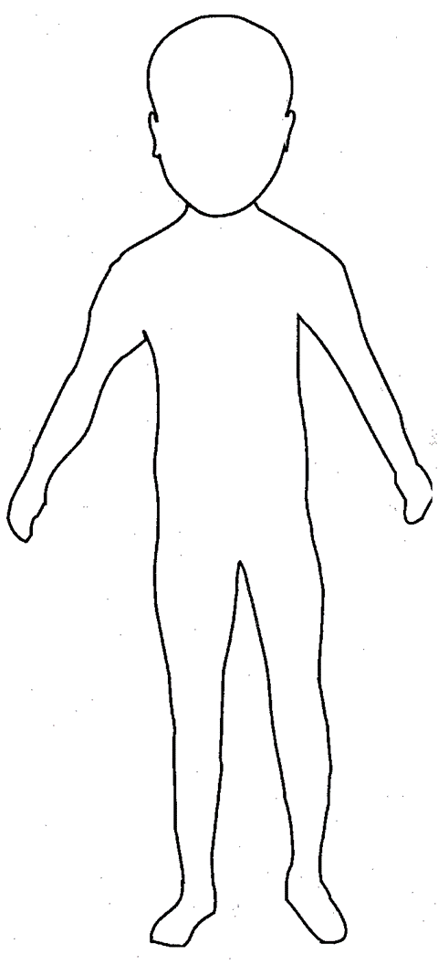
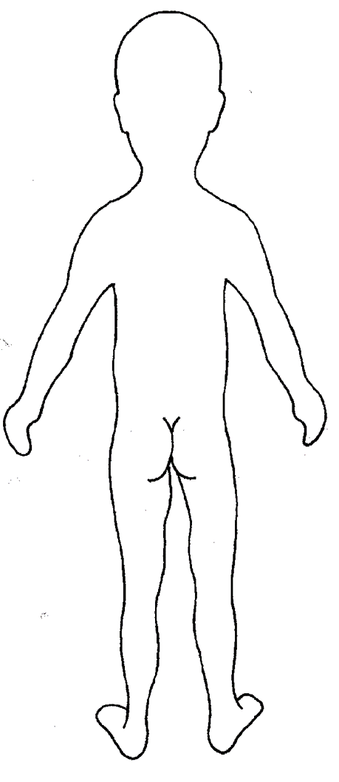

FRONT
BACK

FRONT
BACK
Signature: |  | Date:

Name of Pupil: |  | Date of Birth:
Name of Staff: |  | Date and time of observation:
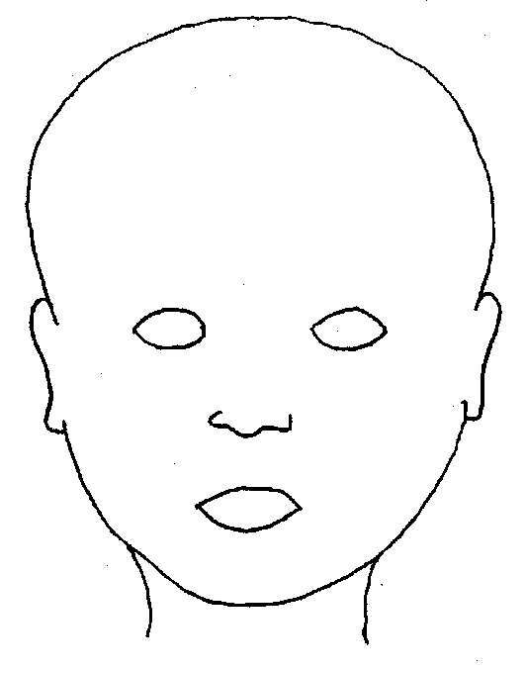


FRONT
BACK

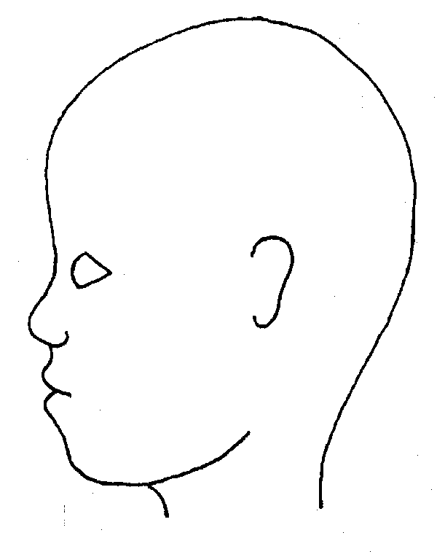
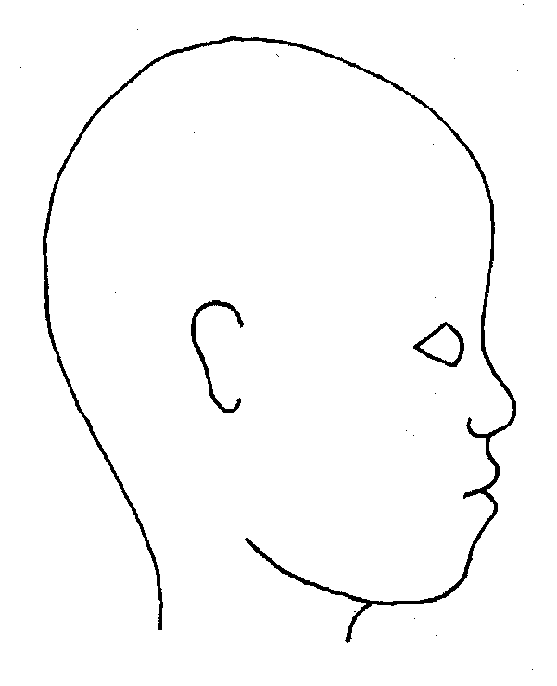

LEFT
RIGHT

Signature: |  | Date:

Name of Pupil: |  | Date of Birth:
Name of Staff: |  | Date and time of observation:


RIGHT
LEFT

PALM

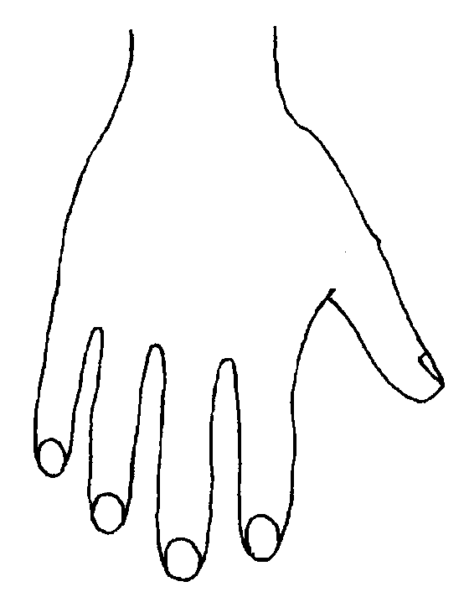
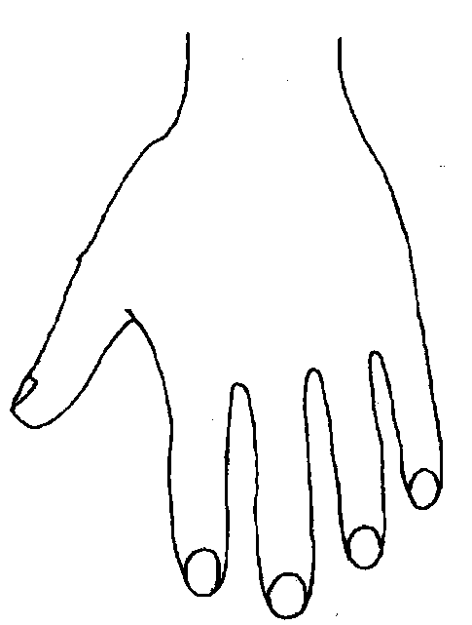
RIGHT

LEFT

BACK

Signature: |  | Date:

Name of Pupil: |  | Date of Birth:
Name of Staff: |  | Date and time of observation:
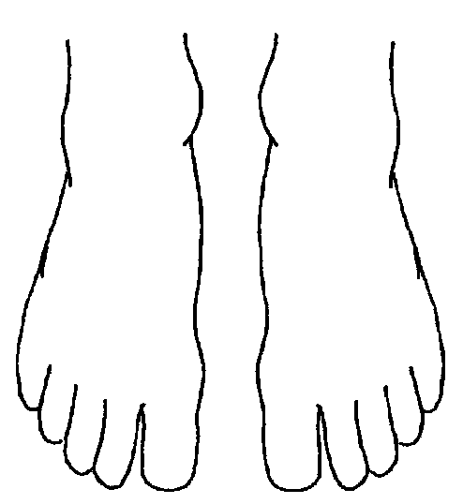
TOP
BOTTOM


RIGHT
RIGHT
LEFT
LEFT



INNER

LEFT


RIGHT
OUTER

Signature: |  | Date:

Appendix 4

Links
Children Act 1989 Care Planning, Placement and Case Review: www.gov.uk/government/publications/children-act-1989-care-planning-placement-and-case-review
Children Act 2004: www.legislation.gov.uk/ukpga/2004/31/contents
Education Act 2002: www.legislation.gov.uk/ukpga/2002/32/section/175
Keeping Children Safe in Education 2025: Keeping children safe in education 2025
Working Together to Safeguard Children 2026: Working Together to Safeguard Children 2026
Inspecting Safeguarding in Early Years, Education and Skills: https://www.gov.uk/government/publications/inspecting-safeguarding-in-early-years-education-and-skills/inspecting-safeguarding-in-early-years-education-and-skills
Teachers’ Standards: https://www.gov.uk/government/publications/teachers-standards
What to do if You’re Worried a Child is Being Abused: www.gov.uk/government/publications/what-to-do-if-youre-worried-a-child-is-being-abused--2
Information Sharing:
www.gov.uk/government/publications/safeguarding-practitioners-information-sharing-advice
Attendance Statutory Guidance
Working together to improve school attendance (applies from 19 August 2024)
Data Protection Guidance
Data protection: The Data Protection Act - GOV.UK (www.gov.uk)
Statutory framework for the early years foundation stage:
https://d.docs.live.net/9b48153fdb534d79/Documents/AfC%20Work/KCSIE_2021_September_guidance.pdf

Early years foundation stage (EYFS) statutory framework
https://www.gov.uk/government/publications/early-years-foundation-stage-framework--2
Statutory guidance for alternative provision: https://www.gov.uk/government/publications/alternative-provision
RBWM Multi-agency Threshold Document:
digital_w_m_multi-agency_threshold_guidance_15_nov_23.pdf (rbwmsafeguardingpartnership.org.uk)

ACEs video: https://www.youtube.com/watch?v=XHgLYI9KZ-A

Mental health and behaviour in schools guidance: https://www.gov.uk/government/publications/mental-health-and-behaviour-in-schools--2
NSPCC: https://www.nspcc.org.uk/keeping-children-safe/childrens-mental-health/
Mind: https://www.mind.org.uk/
Kooth: https://www.kooth.com/
Domestic Abuse Act 2021: https://www.legislation.gov.uk/ukpga/2021/17/contents/enacted
Children Missing Education Statutory Guidance: https://www.gov.uk/government/publications/children-missing-education
Local Guidance:
https://rbwm.afcinfo.org.uk/pages/local-offer/information-and-advice/education/education-welfare-service-ews
Sexual Violence and Sexual Harassment Between Children in Schools and Colleges (DfE September 2021):
https://www.gov.uk/government/publications/sexual-violence-and-sexual-harassment-between-children-in-schools-and-colleges
Beyond Referrals Toolkit:
https://www.csnetwork.org.uk/assets/documents/CSN_BeyondReferrals_SchoolsGuidance_ARTWORK.pdf
When to call the police: https://www.npcc.police.uk/SysSiteAssets/media/downloads/publications/publications-log/2020/when-to-call-the-police--guidance-for-schools-and-colleges.pdf
Stop it Now: https://www.stopitnow.org.uk/concerned-about-a-child-or-young-persons-sexual-behaviour/preventing-harmful-sexual-behaviour/
Child Sexual Exploitation Definition and Guide: www.gov.uk/government/publications/child-sexual-exploitation-definition-and-guide-for-practitioners
Cyber Choices: https://nationalcrimeagency.gov.uk/what-we-do/crime-threats/cyber-crime/cyberchoices
National Cyber Security Centre: National Cyber Security Centre
Preventing youth violence and gang involvement: https://www.gov.uk/government/publications/advice-to-schools-and-colleges-on-gangs-and-youth-violence
Criminal exploitation of children and vulnerable adults: county lines: https://www.gov.uk/government/publications/criminal-exploitation-of-children-and-vulnerable-adults-county-lines
Sharing nudes and semi-nudes: how to respond to an incident:
https://www.gov.uk/government/publications/sharing-nudes-and-semi-nudes-advice-for-education-settings-working-with-children-and-young-people/sharing-nudes-and-semi-nudes-how-to-respond-to-an-incident-overview
Searching, Screening and Confiscation: https://www.gov.uk/government/publications/searching-screening-and-confiscation
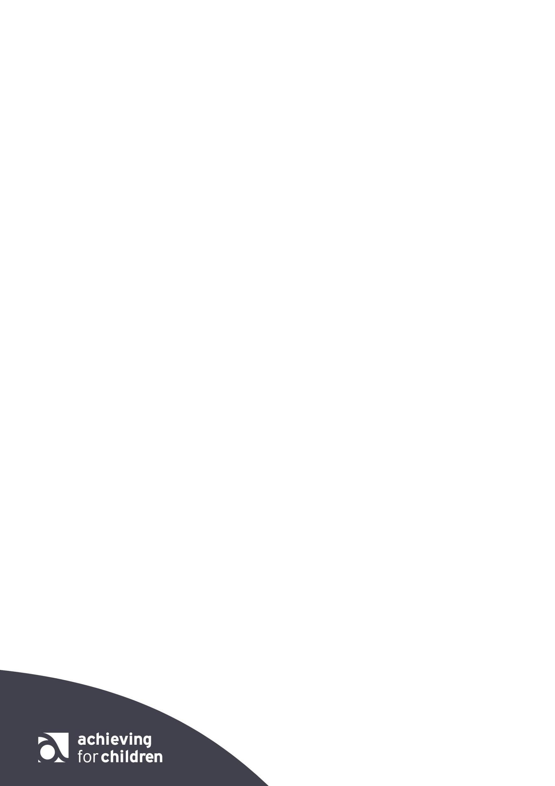
Female Genital Mutilation Statutory Guidance: www.gov.uk/government/publications/multi-agency-statutory-guidance-on-female-genital-mutilation
Guidance Forced Marriage: www.gov.uk/guidance/forced-marriage
Asian Women’s Resource Centre: https://www.asianwomencentre.org.uk/
Modern slavery: how to identify and support victims: https://www.gov.uk/government/publications/modern-slavery-how-to-identify-and-support-victims
Looking After Someone Else’s Child: www.gov.uk/looking-after-someone-elses-child
Protecting Children from Radicalisation: The Prevent Duty: www.gov.uk/government/publications/protecting-children-from-radicalisation-the-prevent-duty
Educate Against Hate: Educate against hate
Papyrus: https://www.papyrus-uk.org/suicide-prevention/
RCPCH updated guidance on fabricated or induced illness: https://childprotection.rcpch.ac.uk/resources/perplexing-presentations-and-fii/
Role and Responsibilities of the Designated Teacher: www.gov.uk/government/uploads/system/uploads/attachment_data/file/269764/role_and_responsibilities_of_the_designated_teacher_for_looked_after_children.pdf
AfC Virtual School: https://www.afcvirtualschool.org.uk/
Family Help Assessment: https://rbwmsafeguardingpartnership.org.uk/p/safeguarding-children/early-help-and-intervention
Guidance for Safer Working Practice:
Contextual Safeguarding: https://contextualsafeguarding.org.uk/about/what-is-contextual-safeguarding

RBWM threshold doc:
digital_w_m_multi-agency_threshold_guidance_15_nov_23.pdf (rbwmsafeguardingpartnership.org.uk)
Child Missing Education: https://rbwm.afcinfo.org.uk/pages/community-information/information-and-advice/schools-and-education/educational-support-services/education-welfare-service
Criminal Exploitation of Children and Vulnerable Adults: County Lines:
https://www.gov.uk/government/publications/criminal-exploitation-of-children-and-vulnerable-adults-county-lines
Teaching Online Safety: https://www.gov.uk/government/publications/teaching-online-safety-in-schools
Children who run away or go missing from home or care: https://www.gov.uk/government/publications/children-who-run-away-or-go-missing-from-home-or-care
NSPCC Responding to a child’s disclosure of abuse: https://www.youtube.com/watch?v=bvJ5uBlGYgE
SPA referral form: https://rbwmsafeguardingpartnership.org.uk/p/safeguarding-children/concerned-about-a-child
Guidance for safer working practice 2019: https://d.docs.live.net/9b48153fdb534d79/Documents/AfC%20Work/keeping-children-safe-in-education-2021-caspar-briefing.pdf (WIthin KCSIE)
Guidance for safer working practice addendum April 2020: https://www.safeguardingchildren.co.uk/wp-content/uploads/2020/04/Guidance-For-Safer-Working-Practice-COVID-addendum-April-2020.pdf
Manor Green physical intervention training: https://www.manorgreenschool.co.uk/training-and-services/team-teach - Can be arranged through Peer schools support
Price training: https://www.pricetraining.co.uk/your-sector/schools-education/
Positive environments where children can flourish: https://www.gov.uk/government/publications/positive-environments-where-children-can-flourish/positive-environments-where-children-can-flourish
Use of reasonable force: https://www.gov.uk/government/publications/use-of-reasonable-force-in-schools

Appendix 5

The Seven Rs
Receive
Listen to what is being said, without displaying shock or disbelief. Accept what is said and take it seriously. Make a note of what has been said as soon as practicable.
Reassure
Reassure the pupil /student, but only as far as is honest and reliable. Do not make promises you may not be able to keep, e.g.: “I’ll stay with you”, or “everything will be alright now” or “I’ll keep this confidential”. Do reassure, e.g. you could say “I believe you”, “I am glad you came to me”, “I am sorry this has happened”, “we are going to do something together to get help”.
Respond
Respond to the pupil/student only as far as is necessary for you to establish whether or not you need to refer this matter, but do not interrogate for full details.
Do not ask ‘leading’ questions, i.e. “did he touch your private parts?” or “did she hurt you?”. Such questions may invalidate your evidence (and the child’s) in any later court proceedings.
Instead, make use of open ended questions which offers the child the opportunity to provide more information about an event in a way that is not leading, suggestive or putting them under pressure. Open questions may use: How? When? Who? Where?
Questions beginning with the phrases “tell me”, “describe” or “explain” are useful:
- Tell me what happened, tell me who was there….
- Explain what you mean when you say….
- Describe the place to me….
- Do not criticise the alleged perpetrator; the pupil may care about him/her, and reconciliation may be possible.
- Do not ask the pupil to repeat it all for another member of staff. Explain what you have to do next and whom you have to talk to. Reassure the pupil that it will be the designated lead for safeguarding or Headteacher.
Report
Share concerns with the DSL as soon as possible. If you are unable to contact your DSL, deputy DSL, or most senior member of staff, if the child is at risk of immediate harm, you MUST contact Achieving for Children SPA service or Police.
If you are dissatisfied with the response from the DSL or children’s social work, you should ask for the decision to be reconsidered, giving your reasons for this.
A formal referral or any urgent medical treatment must not be delayed by the unavailability of designated staff.
Record
If possible, make some very brief notes at the time and write them up as soon as possible. Keep your original notes on file.
Any member of staff receiving a disclosure of abuse from a child or young person, or noticing signs or symptoms of possible abuse in a child or young person, will make a written record as soon as practical, recording the disclosure using the child’s own words, what was said or seen and the location both of the abuse and the disclosure.
Record the date, time, place, person’s present and noticeable non-verbal behaviour, and the words used by the child. If the child uses sexual ‘pet’ words, record the actual words used, rather than translating them into proper words.
A record of a concern, suspicion or allegation should be made at the time of or as soon as possible after the event. Dates and times of events should be recorded as accurately as possible, together with a note of when the record was made.
Record facts and observable things, rather than your ‘interpretations’ or ‘assumptions’.
A record should be made of any visible marks, bruising or injuries to a child that give cause for concern. This may be completed on a body map. (See Appendix 3). The child should not be examined intimately or pictures taken of any injuries / marks.
All records must be signed and dated clearly with the name of the signatory clearly printed. Children MUST NOT be asked to make a written statement themselves or to sign any records. All records of a child protection nature (handwritten or typed) are passed to the DSL.
Remember
Support the child: listen, reassure, and be available. Complete confidentiality is essential. Share your knowledge only with appropriate professional colleagues.
Try to get some support for yourself if you need it.
Review
- Has the action taken provided good outcomes for the child?
- Did the procedure work?
- Were any deficiencies or weaknesses identified in the procedure?
- Have these been remedied?
- Is further training required?

